

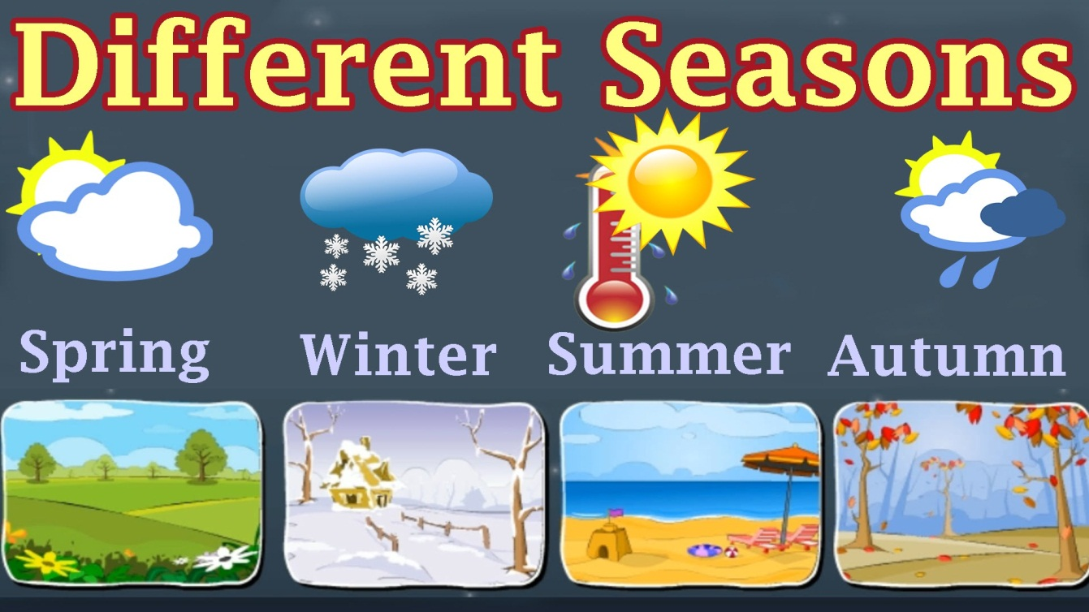

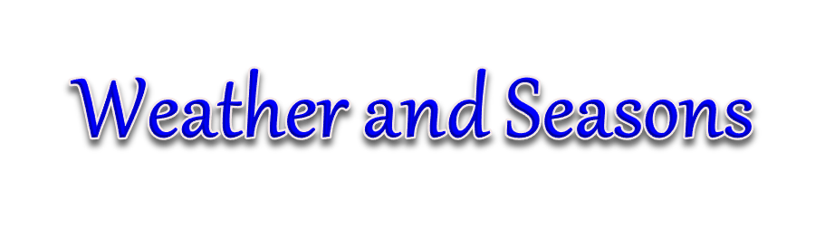

1. Pre-Test
2. Vocabulary/Expressions/phrases
3. Conversation Practice:
4. Grammar Focus:
5. Worksheet

5.1: Listening

5.2: Speaking

5.3: Reading

5.4: Writing

6. Post-test

***Lesson objectives:***

**Student(s) will be able to:**

* Know the 4 seasons (three in Thailand)
* Talk about each season and understand
* Know about different types of weather
* Describe a day seeing the weather

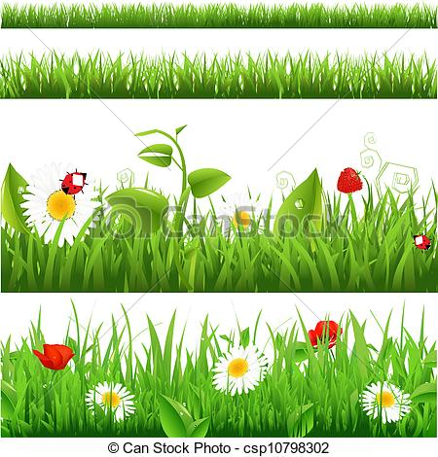

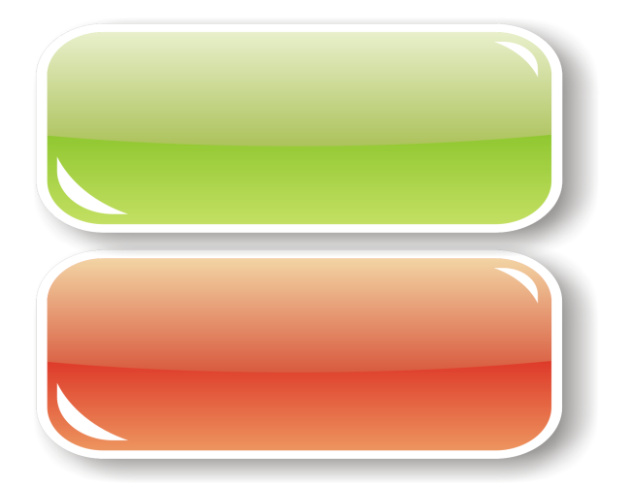****



**THE WEATHER AND THE SEASONS**

**A. WHAT’S THE WORD?**

**snowing foggy raining clear windy**

1. Take an umbrella. It’s raining .
2. Be careful when you drive home. It’s hard to see because it’s so ______.
3. It’s cold! I think it will be ____________ soon.
4. There isn’t a cloud in the sky. It’s a ___________ blue sky!
5. The leaves are blowing off the trees. It’s really _____________!

**B. MATCHING ASSOCIATIONS**



C 1. snowstorm a. flashes of light in the sky

2. lightening b. very strong winds and rain

3. thunderstorm c. cold winds and snow

4. hurricane d. warm rain and noises in the sky

5. winter e. flowers bloom

6. spring f. leaves fall

7. summer g. cold temperatures

8. autumn h. hot temperatures

**C. FAHRENHEIT AND CELSIUS**

Look at the thermometer. Read the sentence and choose the correct   
 temperature.

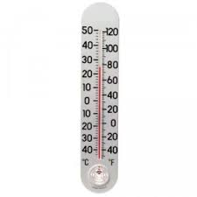

1. “It’s very hot today.” a. 30 °C b. 13°C
2. “It’s very cold outside.” a. 15° C b. -15°C
3. “It’s a nice warm day.” a. 70°F b. 17°F
4. “It’s snowing.” a. -5°C b. 5°C
5. “It’s very hot today!” a. 40 °F b. 40°C
6. “What a big snowstorm!” a. 10°F b. 10°C

**D. WEATHER TALK**



***cloudy foggy lightening***

***snowstorm thunderstorm drizzling***

***hurricane muggy sunny***

1. It’s a clear sunny day. Let’s go to the beach!
2. It isn’t raining very hard. It’s just ________________.
3. I don’t like it when the sky is grey and ______________.
4. My hair gets frizzy when it’s _____________.
5. I hear it’s going to be freezing tomorrow and we’re going to

have a big ________________.

1. My children always hold their ears when there’s loud ____.
2. What a terrible _____________! All the trees in our

neighbourhood were destroyed.

1. Look up at the sky! Did you see that flash of _____________?
2. I’ll open the blinds to see if it’s clear or foggy today. Oh! It’s ___________ I can’t see a thing!

**E. A GOOD IDEA / NOT A GOOD IDEA**

1. A. It’s windy. I think I’ll fly my kite.

B. a. That’s a good idea.

b. I’m not so sure you should.



2. A. It’s sleeting. Why don’t we have a picnic?

B. a. That’s a wonderful idea!

b. Let’s wait until another time.

3. A. It’s freezing. I’ll turn on the heat.

B. a. Please do.

b. I wouldn’t recommend that.

4. A. It’s hailing! Let’s go sailing!

B. a. Are you out of your mind?!

b. I’d love to.

 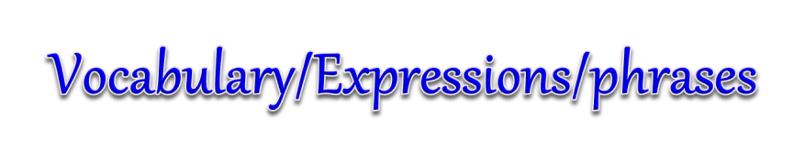

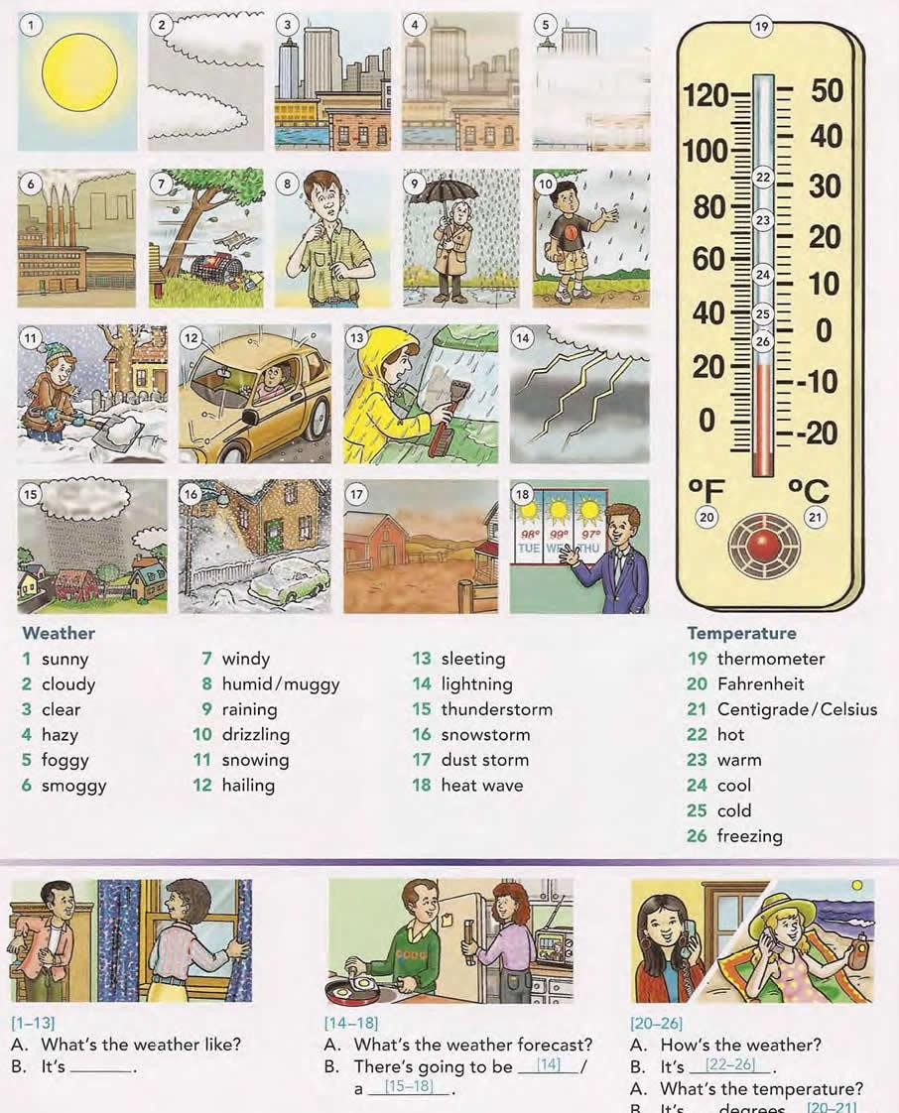

|  |  |  |  |
| --- | --- | --- | --- |
| **Weather** |  |  | **Temperature** |
| 1. sunny 2. cloudy 3. clear 4. hazy 5. foggy   6 smoggy | 1. windy 2. humid/muggy 3. raining 4. drizzling 5. snowing 6. hailing | 1. sleeting 2. lightning 3. thunderstorm 4. snowstorm 5. dust storm 6. heat wave | 1. thermometer 2. Fahrenheit 3. Centigrade/Celsius 4. hot 5. warm 6. cool 7. cold 8. freezing |

***Weather conversation 2 people***

1. What's the weather like?
2. It’s.................... Use numbers 1 -13
3. What's the weather forecast?
4. There's going to be _________ use number 14______/ a __________use numbers 15 - 18
5. How's the weather?
6. It's ______________ use numbers 22 - 26

A. What's the temperature?

B. It is ___________ degree use numbers 20 - 21

**Seasons**

Four seasons: 1. Spring Three seasons in Thailand:

2. Summer 1. The hot season

3. Autumn (fall) 2. The cold season

4. Winter 3. The rainy season

Practice: Which season do you like and why?

**Autumn**

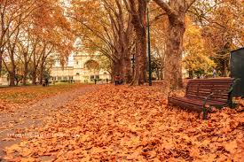 I like………… because……………

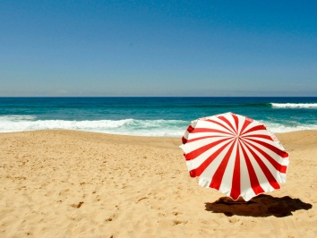

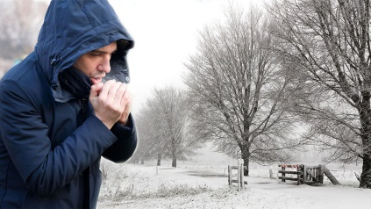

**Summer**

**Autumn**

**Winter**

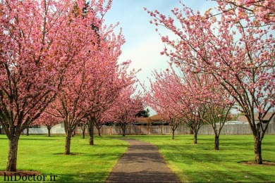

**Winter**

**Spring**

What season **do** you like?

What season **does** your sister like?

**What** **can** you do in winter / spring / summer / autumn?

**I can:**

* Ski

|  |
| --- |
| We can skate. |
| We can't skate. |
| Can you skate? |

* Skate
* Play tennis
* Play basketball / football
* Play badminton
* Play ice-hockey
* Play snowballs

*Example*

* I can play ice-hockey in winter.
* I can ………………………………………………
* I can ………………………………………………
* I can ………………………………………………
* I can ………………………………………………
* I can ………………………………………………

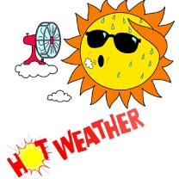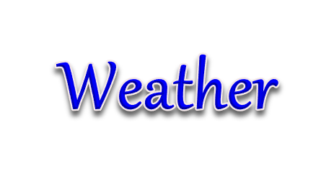

|  |  |
| --- | --- |
| It's sunny. | à¸à¸¥à¸à¸²à¸£à¸à¹à¸à¸«à¸²à¸£à¸¹à¸à¸ à¸²à¸à¸ªà¸³à¸«à¸£à¸±à¸ sunny weather |
| It's hot. | à¸à¸¥à¸à¸²à¸£à¸à¹à¸à¸«à¸²à¸£à¸¹à¸à¸ à¸²à¸à¸ªà¸³à¸«à¸£à¸±à¸ hot weather |
| It's warm. | à¸à¸¥à¸à¸²à¸£à¸à¹à¸à¸«à¸²à¸£à¸¹à¸à¸ à¸²à¸à¸ªà¸³à¸«à¸£à¸±à¸ warm weather |
| It's cold. | à¸à¸¥à¸à¸²à¸£à¸à¹à¸à¸«à¸²à¸£à¸¹à¸à¸ à¸²à¸à¸ªà¸³à¸«à¸£à¸±à¸ cold weather |
| It's cloudy. | à¸à¸¥à¸à¸²à¸£à¸à¹à¸à¸«à¸²à¸£à¸¹à¸à¸ à¸²à¸à¸ªà¸³à¸«à¸£à¸±à¸ cloudy weather |

|  |  |
| --- | --- |
| It's foggy. | à¸à¸¥à¸à¸²à¸£à¸à¹à¸à¸«à¸²à¸£à¸¹à¸à¸ à¸²à¸à¸ªà¸³à¸«à¸£à¸±à¸ foggy weather  à¸à¸¥à¸à¸²à¸£à¸à¹à¸à¸«à¸²à¸£à¸¹à¸à¸ à¸²à¸à¸ªà¸³à¸«à¸£à¸±à¸ windy weather |
| It's windy. |  |
| It's rainy. | à¸à¸¥à¸à¸²à¸£à¸à¹à¸à¸«à¸²à¸£à¸¹à¸à¸ à¸²à¸à¸ªà¸³à¸«à¸£à¸±à¸ rainy weather |
| It's snowy | à¸à¸¥à¸à¸²à¸£à¸à¹à¸à¸«à¸²à¸£à¸¹à¸à¸ à¸²à¸à¸ªà¸³à¸«à¸£à¸±à¸ snowy weather |

 **

**Hot weather:**

* Stifling (hot, uncomfortable, hard to breath)
* Humid (hot and damp)
* Scorching (extremely hot, can be used in positive contexts)
* Boiling (very hot, usually used in negative contexts)
* Heatwave (a period of very hot temperatures)

**Wet weather:**

* Damp (mildly wet weather)
* zDrizzle (very light rain)
* Downpour / pouring down (very heavy rain)
* Torrential rain (extremely heavy rain)
* Shower (raining for a short duration)

**Windy weather**

* Breeze (gentle wind, usually used in a positive way)
* Blustery (very windy, usually negative)
* Gale force wind (extremely windy)

**Mist and fog**

* Haze/hazy (light mist, usually caused by heat)
* Mist/misty (light fog, usually caused by drizzle)
* Fog/foggy (quite thick, associated with cold weather)
* Smog (mixture of fog and pollution)

**Idioms we might use when talking about the weather**

* Weather the storm – to wait for a storm (or trouble) to finish.
* Come rain or shine - If I say I'll be at a place come rain or shine, I mean that I can be relied on to turn up; nothing, not even the vagaries of British weather, will deter me or stop me from being there.
* Dry/wet spell – a period of dryness or wetness
* The heavens open - When the heavens open, it suddenly starts to rain heavily.
* Raining cats and dogs – raining very heavily
* A storm is brewing – the atmosphere/sky indicates that a storm is on its way. It can also be used more generally to refer to trouble on its way.

**Conversation questions about the weather**

* Can you describe the types of weather you get in your country?
* How does the weather affect the way you live?
* What is your favourite type of weather?
* What is your favourite season?
* Do you think the weather affects people’s mood?
* Are there any festivals associated with different seasons in your country?
* If you were to choose a country to live in other than your own, would part of your decision be based on the weather of that country?
* Have you ever experienced extreme weather?
* Has the weather ever destroyed your plans?
* Do you think weather patterns are changing?
* Do you prefer your holidays to be in hot weather e.g. a beach holiday, or cold weather e.g. snow, skiing etc.?
* Do you think the weather can affect our health?
* Which season do you think is the most beautiful in nature?
* Do you think that extreme weather can affect the economy in a country?
* How does weather determine the type of house a person lives in?
* Do you check weather reports regularly?
* Why is it important to know future weather conditions in advance?

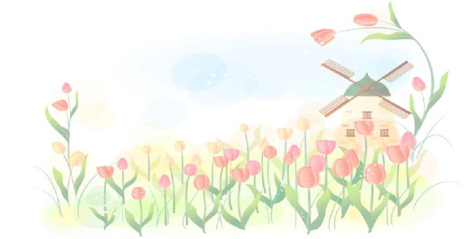

 

Using its and there

We often use "It's" as the subject of a sentence about weather:

With an adjective: It's hot today.

With a verb: It's raining again.

We can use "There" with a noun

There will be more snow later.  
There's a lot of fog about.

(It's = it is)

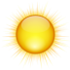**Weather adjectives**

Here are some common adjectives to describe weather.

sunny (when there's a lot of sunshine): "It's sunny today

hot: "I like hot weather."

cold: "We have cold winters in the UK."

mild = when the weather isn't cold: "Spring is usually a mild season."

fine = a word to mean "nice" when we describe the weather: "It will be a fine, sunny day."

windy = when there's a lot of wind: "Be careful when you go out. It's very windy."

wet = when it rains a lot: "The roads are wet. Take care."

dry = when there's no rain: "It's going to be a long, dry summer."



cloudy: "Today will be cloudy."



overcast = when the sky is completely grey: "It's overcast and depressing today."

misty = when there is low cloud in the morning: "It's quite misty this morning."



foggy = when you can't see in front of you because there is low clouds: "It's foggy today in the mountains."

frosty = when it freezes overnight and the grass, etc is icy and white: "It's going to be frosty tomorrow morning."

icy = when it freezes and water turns to ice: "Road conditions are icy this morning."

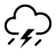

stormy: "You can expect stormy weather in winter."

**Weather verbs**

raining: "It's raining again."  
"It always rains in summer here""

("rainy" is also an adjective: "It's a rainy day.")

snowing: "It's snowing hard. Let's go and build a snowman!"  
"It usually snows in the winter here."

**Weather nouns**

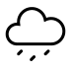rain: "We expect rain later."

You can also say "light rain", "heavy rain", or "showers" (rain that only lasts for a few minutes.)

sunshine = "The weather forecast says there'll be sunshine later."

fog: "I don't like driving in fog."

mist: "There's often some mist in the early morning."

ice: "Be careful of the ice on the roads."



snow: We had lots of snow last winter.

clouds = there are different types of clouds, such as rain clouds, snow clouds and storm clouds.

floods = when there's too much rain and the fields or roads are covered in water: "Last winter there were lots of floods."

The adjective is "flooded": "All the roads are flooded."

The verb is "to flood": "The river flooded twice last year."

storm = when you get heavy rain and strong winds, and maybe also thunder (noise) and lightning (electricity).

**Other typical English weather vocabulary**

strong wind = when there is a lot of force or power in the wind

cold snap = when it is cold for a period of time

dry spell = when it is dry for a period of time

sunny spell = when it is sunny for a period of time

partly cloudy = when there is both cloud and sunshine

a heatwave = when it is hotter than usual, for a long period of time

high temperatures (rising temperatures) = when it is hot

low temperatures (falling temperatures) = when it is cold

above / below freezing = when the temperature is above 0C or below 0C.  
 We also say "minus". For example -2C is "minus two"

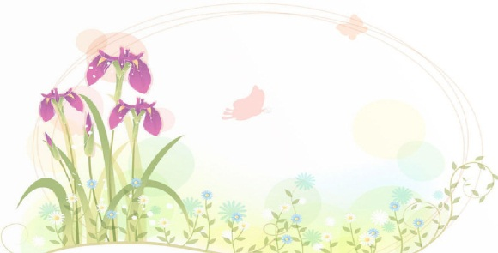

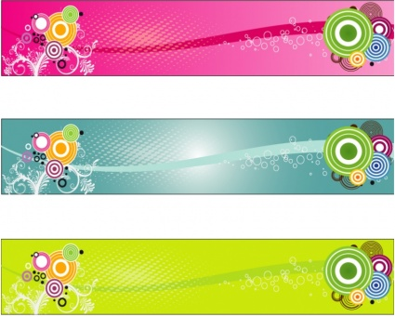****

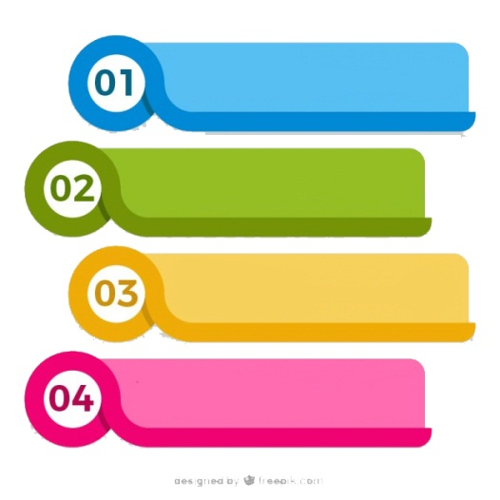

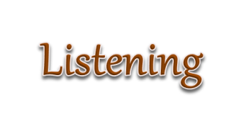

**1. Listen to the audios and fill up the gaps**

**A:**  It's such a _______ day.  
**B:**  Yes, it is.  
**A:**  It looks like it may _______ soon.  
**B:**  Yes, and I _______ that it does.  
**A:**  ________ is that?  
**B:**  I really love how _______ clears the air.  
**A:**  Me too. It always smells so ________ after it rains.  
**B:**  Yes, but I love the night _________ after it rains.  
**A:**  Really? Why is it?  
**B:**  Because you can see the _________ perfectly.  
**A:**  I really hope it rains _________.  
**B:**  Yeah, me too.

**2. A:**  Isn't it a __________ day?  
**B:**  It really is.  
**A:**  It seems _______ it may rain today.  
**B:**  Hopefully it will.  
**A:**  How _______?  
**B:**  I like how ____________ the sky gets after it rains.  
**A:**  I feel the same way. It ______________ so good after it rains.  
**B:**  I especially love the ____________ air when it rains.  
**A:**  Really? Why?  
**B:**  The stars look so much closer after it _____________.  
**A:**  I really ___________ it to rain today.  
**B:**  Yeah, so do _______.

**3. A:**  Don't you _____________ it's nice out?  
**B:**  Yes, I think so too.  
**A:**  I think that it's __________ to rain.  
**B:**  I hope that ________ does rain.  
**A:**  You __________ the rain?  
**B:**  The sky looks so ___________ after it rains. I love it.  
**A:**  I understand. ____________ does make it smell cleaner.  
**B:**  I love most how it is at night _____________ it rains.  
**A:**  How come?  
**B:**  You can ___________ the stars so much more clearly after it rains.  
**A:**  I would _________ for it to rain today.  
**B:**  I would too.

 

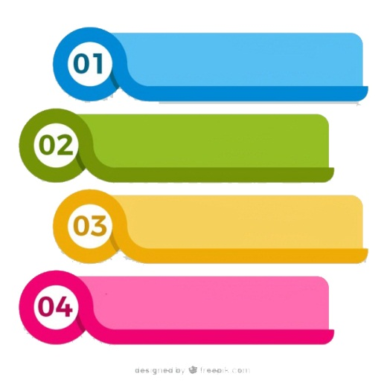



Flooding in Thailand is a disaster. Thai residents are afraid of flooding. It means that an overflow of water will submerge land and houses. Massive flooding will destroy large parcels of rice farmland. Local residents leave their homes as they walk in the floodwaters. Someone stands knee deep in brown water. Others have to walk through waist-deep water. Most of them leave their home to stay at makeshift evacuation center. They rest under mosquito nets. There is a donation to help people who are impacted by the floods. They wait for food handouts and sometimes use boats during an evacuation from a flooded area. Many residents stock pile of food and drinking water. The good things we can see during flooding are loving and helping between people.

1. Why Thai residents are afraid of flooding?

………………………………………………………………………………..

1. Where do the residents stay after they leave their homes?

…………………………………………………………………………………

3. Why do many people make a donation to the residents?

…………………………………………………………………………………

4. What do the residents do while they are at the makeshift evacuation

center?

..………………………………………………………………………………..

5. What are the good things we can see during flooding?

………………………………………………………………………………



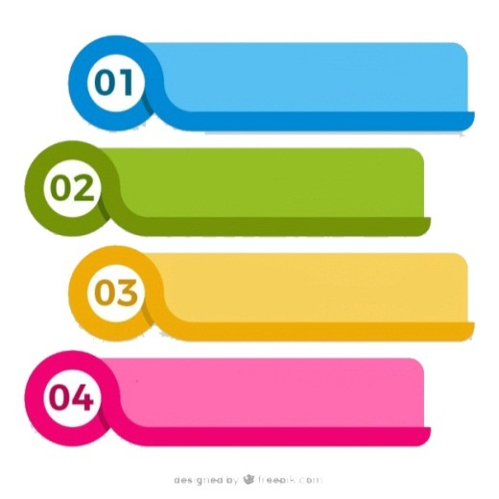

**Ask the following questions to your friend and write their answers.**

* 1. What is your favorite season?

………………………………………………………………………………

* 1. What do you think of when you think of winter?

………………………………………………………………………………

* 1. What are some things your family did when you were a child in spring?

………………………………………………………………………………

* 1. What is the worst season in your country?

………………………………………………………………………………

* 1. Does it snow in your hometown in the winter? Did you use to make snowmen?

………………………………………………………………………………

* 1. What is your favorite thing to do in summer?

………………………………………………………………………………

* 1. What festivals or celebrations does your country have during the changing of the seasons?

………………………………………………………………………………

* 1. Do you ever go hiking when the leaves change in fall?

………………………………………………………………………………

* 1. Where is the best place to be in summer? How about winter?

………………………………………………………………………………

* 1. Does your country have a special food for any of the seasons?

………………………………………………………………………………



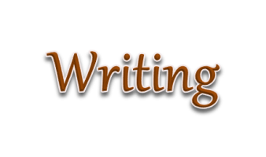

**Look at the pictures.**

**Talk about the weather.**

**Write the numbers.**

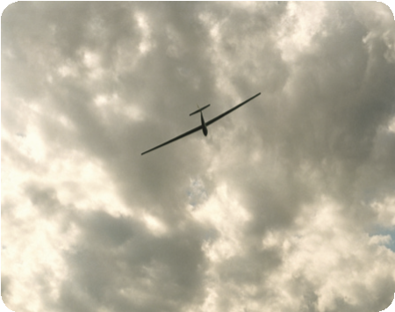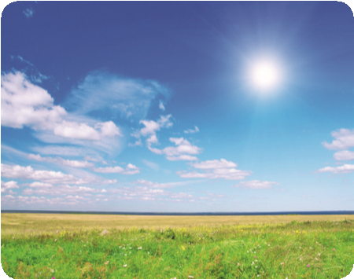

**3**

**2**

**1**

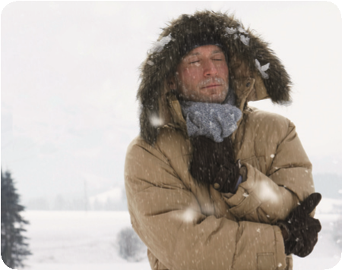

**6**

**5**

**4**

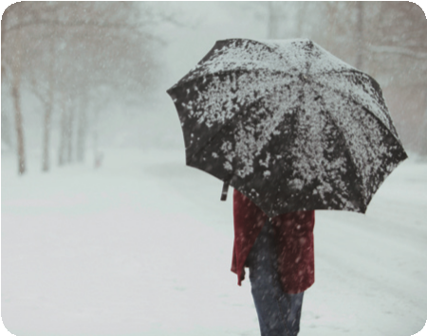

It’s warm. It’s could. It’s raining.

It’s sunny. It’s snowing. It’s cloudy

**Write the seasons. Check in the Longman Photo Dictionary.**

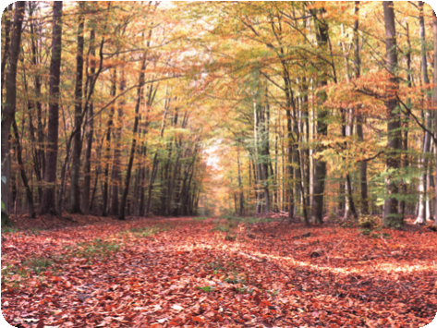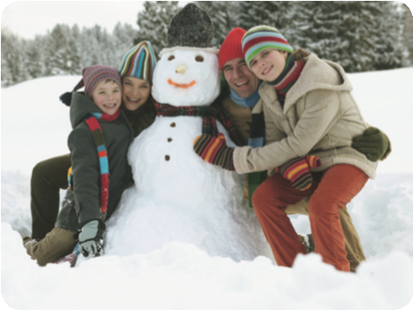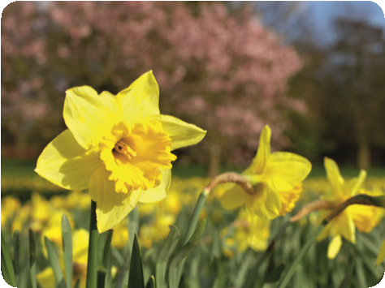

**Practise reading the texts. Write the season.**

***Spring Summer Autumn (fall) Winter***

I like ……………………… I like …………………….. spring

It is hot and sunny. It is very cold. summer I go on holiday.

My children play in the snow. autumn

I like ………………………. I like ………………………….

It is not very cold. The children go back to school.

I like the flowers. The leaves fall from the trees.

**Which season do you like? Why?**

I like ................................................................................................................................................



**1. What’s the weather like today?**

**Look at the pictures. What’s the weather like? Talk to your partner.**

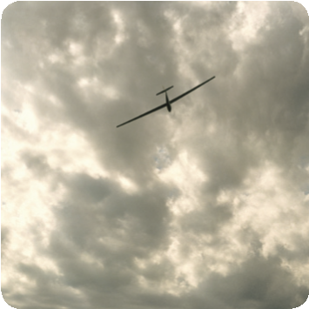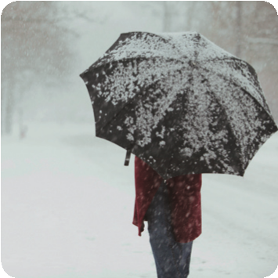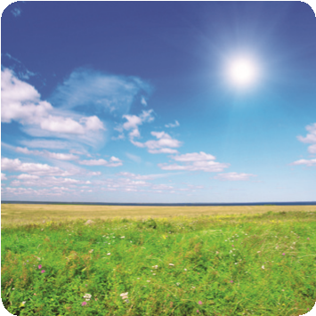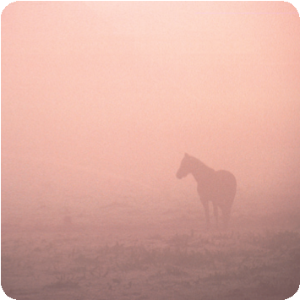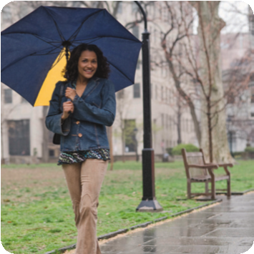

**A**

*Check in the Longman Photo*

*Dictionary, Write the letter.*

**D**

**B**

**C**

1. It’s sunny.

2. it’s windy.

3. ti’s doudy.

4. ti’s foggy.

5. it’sraining/rainy/

6. it’s snowing/snowy

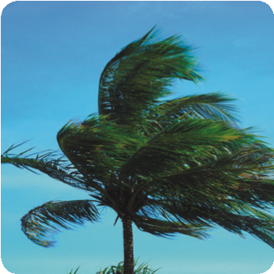

**E**

**F**

**Practise with your partner.**

*What’s the weather*

*Like today:*

*It’s sunny.*

**Look!**

It’s 10˚ = It’s ten degrees.

**2. What’s the temperature?**

**Practise with your partner.**

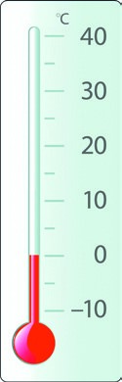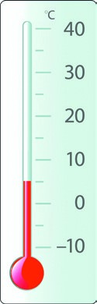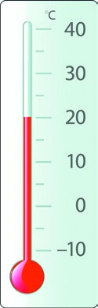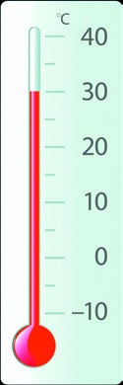**A B C D**

**1**

It’s warm.

................

It’s hot.

................

................

It’s cold.

................

**2**

**3**

It’s freezing.

**4**

**Practise with your partner.**

*What’s the weather*

*Like today:*

*It’s ho and sunny.*

*It’s about 30 degrees.*

**4**

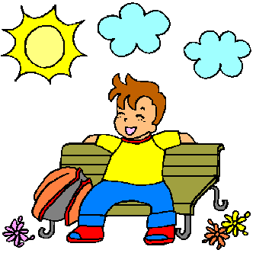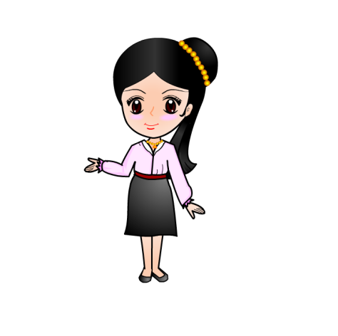

**Practise with your partner.**

A: What’s the weather like today? Write two sentences.

B: ........................................................................................................................................................

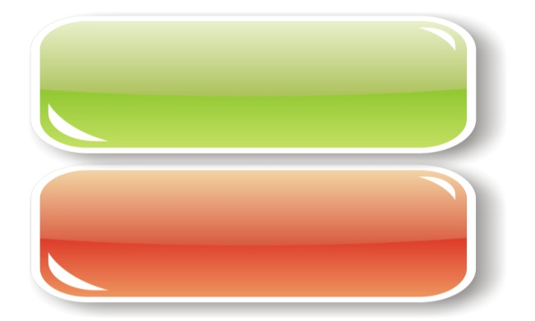

**THE WEATHER AND THE SEASONS**

**A. WHAT’S THE WORD?**

**snowing foggy raining clear windy**

1. Take an umbrella. It’s raining .

2. Be careful when you drive home. It’s hard to see because it’s so __.

3. It’s cold! I think it will be ____________ soon.

4. There isn’t a cloud in the sky. It’s a ___________ blue sky!

5. The leaves are blowing off the trees. It’s really ___________!

**MC900389160[1]B. MATCHING ASSOCIATIONS**

C 1. snowstorm a. flashes of light in the sky

2. lightening b. very strong winds and rain

3. thunderstorm c. cold winds and snow

4. hurricane d. warm rain and noises in the sky

5. winter e. flowers bloom

6. spring f. leaves fall

7. summer g. cold temperatures

8. autumn h. hot temperatures

**C. FAHRENHEIT AND CELSIUS**

 Look at the thermometer. Read the sentence and choose the correct   
 temperature.

1. “It’s very hot today.” a. 30 °C b. 13°C

2. “It’s very cold outside.” a. 15° C b. -15°C

3. “It’s a nice warm day.” a. 70°F b. 17°F

4. “It’s snowing.” a. -5°C b. 5°C

5. “It’s very hot today!” a. 40 °F b. 40°C

6. “What a big snowstorm!” a. 10°F b. 10°C

MC900078792[1]**D. WEATHER TALK**

***cloudy foggy lightening***

***snowstorm thunderstorm drizzling***

***hurricane muggy sunny***

1. It’s a clear sunny day. Let’s go to the beach!

2. It isn’t raining very hard. It’s just ________________.

3. I don’t like it when the sky is grey and ______________.

4. My hair gets frizzy when it’s _____________.

5. I hear it’s going to be freezing tomorrow and we’re going to

have a big ________________.

6. My children always hold their ears when there’s loud ____.

7. What a terrible _____________! All the trees in our

neighbourhood were destroyed.

8. Look up at the sky! Did you see that flash of _____________?

9. I’ll open the blinds to see if it’s clear or foggy today. Oh! It’s ___________ I can’t see a thing!

**E. A GOOD IDEA / NOT A GOOD IDEA**

1. A. It’s windy. I think I’ll fly my kite.

B. a. That’s a good idea.

MC900078822[1] b. I’m not so sure you should.

2. A. It’s sleeting. Why don’t we have a picnic?

B. a. That’s a wonderful idea!

b. Let’s wait until another time.

3. A. It’s freezing. I’ll turn on the heat.

B. a. Please do.

b. I wouldn’t recommend that.

4. A. It’s hailing! Let’s go sailing!

B. a. Are you out of your mind?!

b. I’d love to.