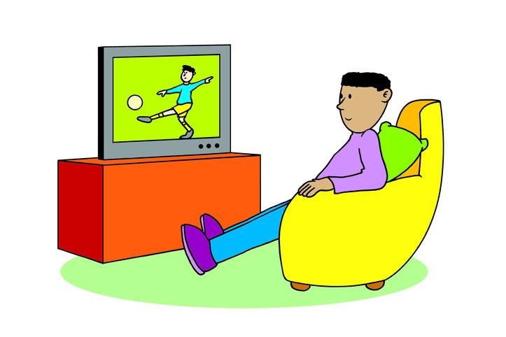

- Pre-Test
- Vocabulary/Expressions/phrases
- Conversation Practice:
- Grammar Focus: Verb to do , action verbs and Yes/No Questions
- Worksheet
5.1: Listening
5.2: Speaking
5.3: Reading
5.4: Writing
6. Post-test

Lesson objectives:
Student(s) will be able to:
- Speak about what they like to do in their free time.
- Identify the Indoor and Outdoor Activities.
- Make simple sentences by applying simple present tense and adverbs of frequency.

surfing go shopping scuba diving playing video games skiing sunbathing surfing the internet hiking swimming horse riding having a picnic snowboarding rollerblading cycling bird watching watching TV eating out playing chess
building sand castles bungee jumping

Indoor | Outdoor summer | Outdoor winter | All season outdoor
2. Vocabulary. Look at the pictures and practice the free time activities.

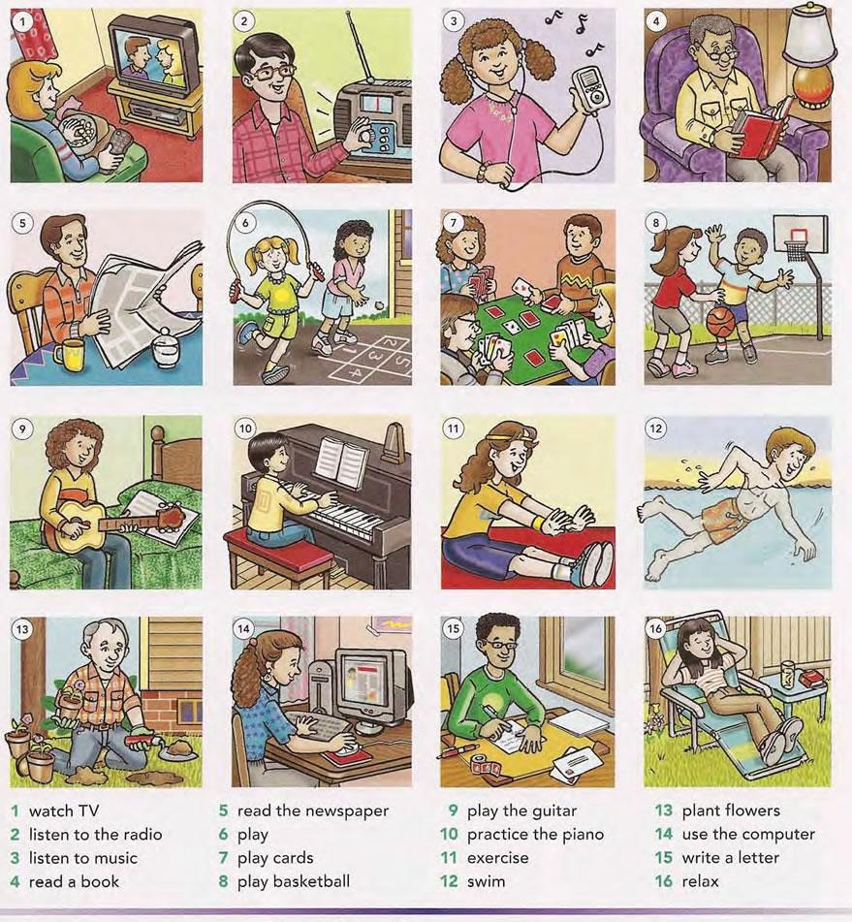

3. Leisure activities
conversation 1

A. Hi. What are you doing?
- II am watching TV.
A. Hi Linda. Are you ___ing____? Example. Are you watching TV?
- No, I am not. I am ___ing_______
A. What is your (husband / wife / son / daughter) doing?
- She / He _____ing________
Conversation 2. What do you like doing in your free time?

I like to go…

swimming/to the beach | camping | bowling
to the movies/mall | traveling
fishing | on picnics/ to the park | cycling
 | skating/ice-skating | horse-riding

I like to play…

chess/ board games | computer games | cards
guitar/ piano/ flute | basketball | football/soccer
 |  | tennis/ badminton
I like…

cooking | watching television | reading
drawing/ painting | surfing the internet | Singing  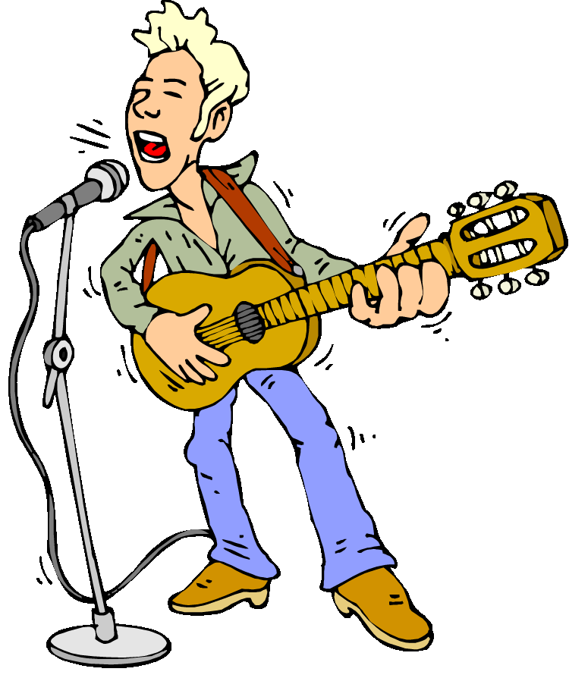
Listening to music | gardening | taking pictures
 | sleeping | chatting with friends

Here are some example sentences you can say about free time.

- I/play/tennis
- Do/you/play/tennis
- I/can/play/tennis
- I/love/play/ing/tennis
- She/play/s/tennis
- Does/she/play/tennis
- She/can’t/play/tennis
- She hate/s/play/ing/tennis
- She/never/play/s/tennis/
- She/always/play/s/tennis
List of adjectives they can use to describe their free time activity:

Relaxing dangerous exciting great fun intelligent
Quiet adventurous interesting amusing peaceful
Energizing frightening competitive okay inspiring

Complete the dialogue with the words in the box and act it out with the student next to you

apple pancakes, cinnamon, cookery book, Friday, mix, smell, sugar, them, tiny pieces of apple, vanilla ice-cream

Wendy: Hi, Tom! Whzat are your plans for this afternoon?
Tom: It’s _________ , no homework, so we have lots of time. Why don’t we make _________ ?
Wendy: That’s great! But I don’t know how to make _________ .
Tom: Let’s look it up in Mum’s _________ . See, it’s easy. We need some flour, eggs, _________ , milk and _________ . Then
we _________ them all. We can also put a little _________ in
to make them taste better. When our pancakes are ready, we can
eat them with strawberry jam and some ________ . What do you think?
Wendy: Mmm, I can already ________ them. Let’s start now, then we’ll be ready when Mum and Bob come home. It’ll be a surprise!

โครงสร้าง S + love/like/dislike/hate + V-ing

1. ถ้าประธาน (Subject, S) เป็นพหูพจน์ ได้แก่
I (ฉัน)
You (คุณ) >>> like
We (พวกเรา)
They (พวกเขา)
2. ถ้าประธานเป็น ( Subject, S ) เป็นเอกพจน์ ได้แก่
He (เขาผู้ชาย)
She (เขาผู้หญิง) >>> likes
It (มัน)

หลักการใช้ Like / Likes
1. ในรูปแบบประโยคบอกเล่า ถ้าประธานเป็นเอกพจน์ กริยา like ต้องเติม s ประธานพหูพจน์ กริยา like ไม่ต้องเติม s เช่น
- We like animal.
- Smith likes turtle.
- She loves dancing.
- He likes playing football.
- I hate cooking.
- I dislike watching T.V.
2. ในรูปแบบประโยคปฏิเสธ เราจะใช้ กริยา to do ( do / does) ช่วย โดยการเติม not ลงหลัง กริยา to do โดยนำไปวางระหว่างประธานกับกริยา like และต้องตัด s ออก เช่น
- do = do not รูปย่อคือ don't
- does = does not รูปย่อคือ doesn't
- We don’t like fruit.
- Sam doesn’t like sport.
- He doesn’t likes playing golf.
- I don’t like cooking.
3. ประโยคคำถาม เราจะใช้ กริยา to do (do/does) วางไว้หน้าประธานหรือหน้าประโยค กริยา like ต้องตัด s ออก การตอบประโยคคำถาม Yes/No question ต้องตอบรับใช้ yes, ตอบปฏิเสธใช้ No, เช่น
- What do you like doing in your free time? - I like reading a science book.
- Do you like reading? - Yes, I do. / No, I don’t.
- Dose she like listening to music? - Yes, she does. / No, she doesn’t.
- Do they like playing football? - Yes, they do. / No, they don’t.

การใช้ like & dislike: ต้องตามด้วย Verb + ing:
1. หลักการเปลี่ยนรูปให้เป็น – ing form
1.1 คํากริยาปกติ เติม – ing ต่อท้ายคํา เช่น cook = cooking / play = playing / read = reading
1.2 คํากริยาที่ลงท้ายด้วย / e / ต้องตัด / e / ก่อนแล้วเติม – ing เช่น dance = dancing / take = taking
1.3 คํากริยาเสียงสั้นก่อนเติม – ing ต้องเติมพยัญชนะตัวท้ายเพิ่มอีกตัวแล้วจึงเติม – ing เช่น get = getting / swim = swimming / run = running
2. Question and Answer Verb – Do/Does
- Do you like getting up early? -Yes, I do. / No, I don’t.
- Do we like swimming now? - Yes, we do./ No, we don’t.
- Does she like cooking at home? - Yes, she does./ No, she doesn’t.
- Does he like driving to work? - Yes, he does. / No, he doesn’t.
Conversation 3
- A: What sport do you like?
- B: I like playing football.
- A: Do you like any sport?
- B: Yes, I like playing basketball. But I don’t like swimming.

Conversation 4
- A: Do you like watching movies?
- B: Yes, I do.
- A: What kind of movies do you like?
- B: I like science movie very much.

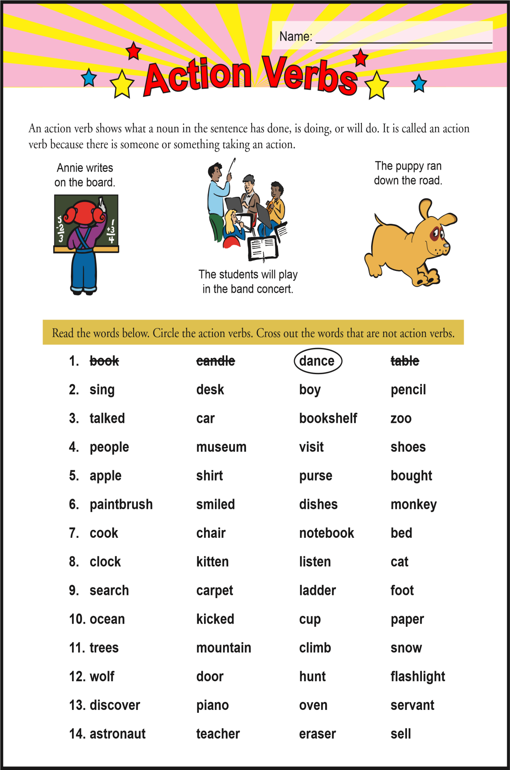

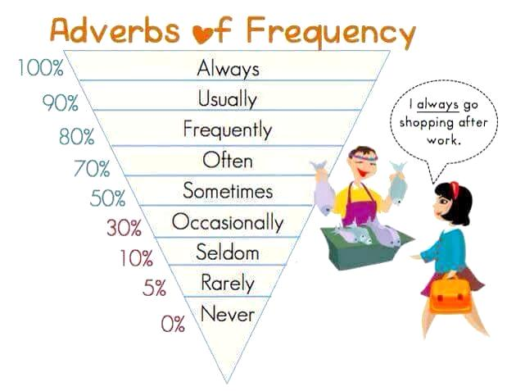

Q: How often do you + Verb1 + noun
A: Subject + adv.F + verb1 + noun

Example:
How often do you play sports?
I sometimes play sports.
I never play sports.

1. Listen to the audio and fill up the gaps
A: Tell me, what do you _______ doing in your spare time?
B: I enjoy _________ and painting.
A: You know how to draw and ________?
B: Yes, I do.
A: When did you _________ how to do that?
B: I learned back in high school.
A: Oh, so you took a ______ class?
B: Yeah, I loved that class.
A: I see that you're ______ talented.
B: Thank you very much.
A: I wish I had a talent like that.
B: I'm sure you have a ________. It's just hidden.

2. A: What kinds of ______ do you like to do?
B: I've always liked to draw and paint.
A: I didn't know you knew how to ______ and paint.
B: I do it every ______ in a while.
A: How long have you known how to _____ that?
B: I first learned how to do it in high school.
A: Did _____ take some sort of art class or something?
B: That was my ________ class.
A: You have got to be talented.
B: Thanks.
A: If only I was talented.
B: You have a talent. You just ________ know what it is yet.

3. A: Are there any _________ you do?
B: When I have time, I sometimes draw and paint.
A: Oh, you actually do that?
B: Every so _______, I do.
A: Did you always know how to draw and paint?
B: I was taught in high _________ how to draw and paint.
A: You had an art class?
B: Exactly, it was my favorite class.
A: Well, it's _______ that you're so talented.
B: I appreciate that.
A: Talent is a _________ thing, I wish I had one.
B: Everyone has a talent. They just need to find it.

This is Mary. She’s eleven. She’s got long brown hair and brown eyes. Her ears are small and her cheeks are chubby.
She gets up at 7 o’clock in the morning, has a shower, gets dressed and has breakfast. She usually has a toast and coffee. She doesn’t like cheese. Then the girl goes to school. She travels by bus. She has lunch at school with her friends. They sometimes have pizza and milkshake. After the lessons they play in the park and they like flying a kite. Mary goes home at 5pm. She has dinner with her mother and father. Her mother likes cooking! Mary goes to bed at 10 pm.
The girl lives in the city. There is a swimming pool next to her house but her school is far. There are lots of shops and supermarkets in her street. There is a café behind her house and Mary goes there at the weekend with her family.
There is a market in front of her house. There are a lot of fruit. She likes eating watermelons and mangoes but she doesn’t like grapes. She likes vegetables.
Now the girl is in her bedroom. It’s big. There are two windows, there is a wardrobe in the room and there is her desk next to the window. There is a chair next to her desk. Now her room is a mess! There are her jeans on the floor and there is one sock on the sofa and one sock on the lamp. Her mother is angry. She says: You can’t go to the park, please tidy up your room! Put those jeans in the wardrobe and find the socks!
Mary likes doing athletics and playing table tennis. Going swimming is fun! But she doesn’t like playing basketball. She is very short!
In the summer Mary would like to go camping with her grandfather! She wouldn’t like to help her grandmother in the garden. It’s boring!

Write YES or NO:

_________ 1. Mary has got short brown hair.
_________ 2. She has a toast and coffee for breakfast.
_________ 3. The children don’t have pizza for lunch.
_________ 4. Her school is next to her house.
_________ 5. There is a café in front of her house.
_________ 6. Mary likes mangoes but doesn’t eat watermelons.
_________ 7. There is a desk behind the wardrobe in her room.
_________ 8. Her room is a mess.
_________ 9. There is one sock under the sofa.
_________ 10. Her mum is scared because there is a mess.
_________ 11. She doesn’t like playing basketball.
_________ 12. She would like to go camping with her grandfather

Choose the right answer:
- The girl gets up at
- eight o’clock
- seven o’clock
- nine o’clock
- She goes to school by:
- car
- helicopter
- bus
- There is a … next to her house.
- supermarket
- café
- swimming pool
- Mary doesn’t like eating
- watermelons
- potatoes
- grapes
- There is a chair
- next to her desk
- behind the wardrobe
c) under her desk
- The girl’s mother asks the girl
- to find the jeans
- to go to the park
- to clean the room.

  - Pair work (Ask your friend about his/her free time activities)
Tick ()
How often do you…

 | usually | always | often | sometimes | never

go to school ?
eat sweets ?
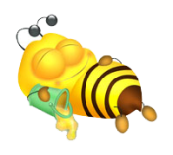
see sweet dreams ?

catch cold ?
listen to music ?

travel by plane ?
drink coffee ?
dance ?

C kook lunch?
How often
do you…
Tick ()

 | usually | always | often | sometimes | never
read books ?
paint pictures ?
write e-mails ?
feed your pet ?
play football ?

2. Speak about your friend.

Example:
He/she always goes to school.
He/she never eats sweets.

Choose the right option.

1.
a. gymnastics
b. swimming
c. acting
3.
a. acting
b. dancing
c. singing

2.
a. singing
b. dancing
c. music

5.
a. acting
b. singing
c. dancing

4.
a. painting
b. music
c. reading

6.
a. cooking
b. rowing
c. knitting

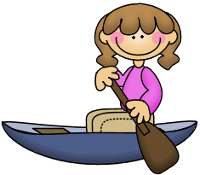
7.
a. cooking
b. rowing
c. knitting

9.
a. rowing
b. fishing
c. camping

8.
a. cooking
b. gardening
c. camping

8.
a. cooking
b. gardening
c. camping

8.
a. cooking
b. gardening
c. camping

8.
a. cooking
b. gardening
c. camping

6.
a. cooking
b. rowing
c. knitting

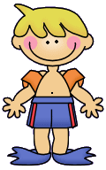
10.
a. writing
b. camping
c. bird watching

12.
a. running
b. hiking
c. reading

11.
a. swimming
b. surfing
c. fishing

8.
a. cooking
b. gardening
c. camping

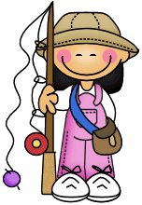
14.
a. reading
b. writing
c. painting

15.
a. reading
b. writing
c. painting

13.
a. hunting
b. fishing
c. camping

18.
a. fishing
b. camping
c. reading

17.
a. drawing
b. acting
c. cooking

16.
a. swimming
b. surfing
c. skating

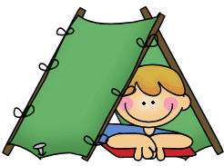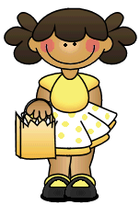
24.
a. drawing
b. singing
c. recycling

21.
a. shopping
b. camping
c. knitting

22.
a. running
b. walking
c. gymnastics

23
a. skiing
b. skating
c. singing

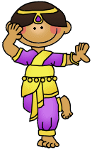
20.
a. singing
b. dancing
c. cooking

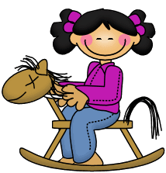
19.
a. horse riding
b. running
c. hiking

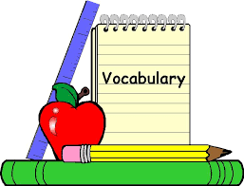

surfing go shopping scuba diving playing video games skiing sunbathing surfing the internet hiking swimming horse riding having a picnic snowboarding rollerblading cycling bird watching watching TV eating out playing chess
building sand castles bungee jumping

Indoor | Outdoor summer | Outdoor winter | All season outdoor

