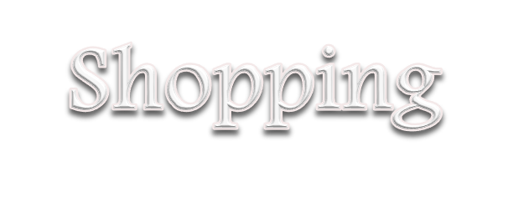



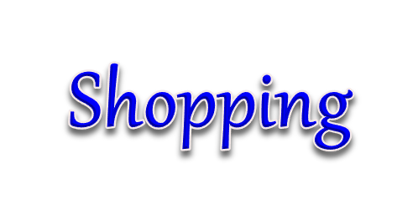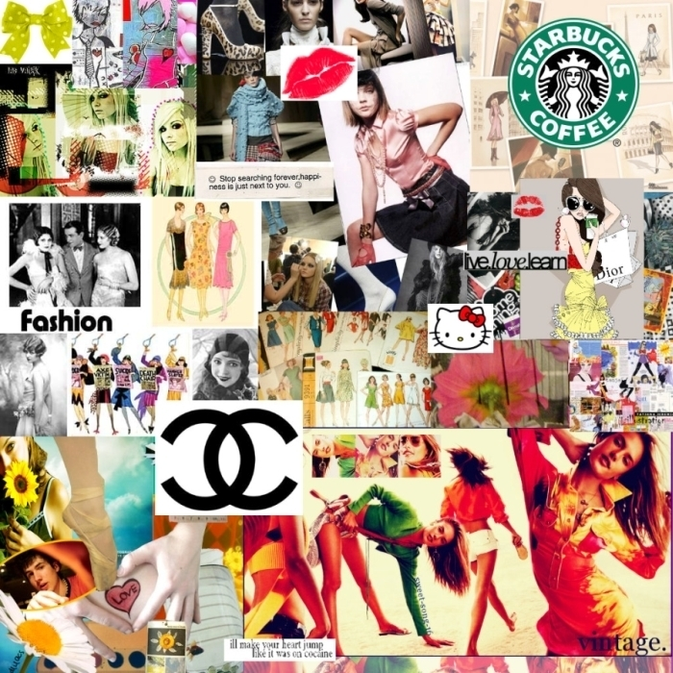

1. **Pre-Test**
2. **Vocabulary / Expressions/phrases**
3. **Conversation Practice:**
4. **Grammar Focus: Present simple tense, Verb to be**
5. **Worksheet**

**5.1: Listening**

**5.2: Speaking**

**5.3: Reading**

**5.4: Writing**

1. **Post-test**



***Lesson objectives:***

**Student(s) will be able to:**

**⬥ Use expressions for shopping**

**⬥ Ask and answer about shopping**

**⬥ Know shopping vocabularies**

**• Clothing**

**• Vegetables**

**• Electronics**

**• Prices**

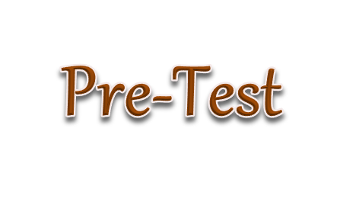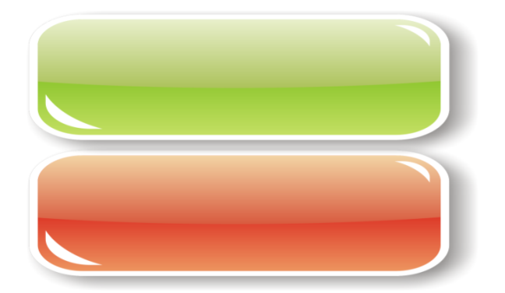

***Part I: Choose the correct answer***

1. Customer: May I see _____ ones?

a. this

b. that

c. those

d. one

2. A: Which trousers do you want to buy?

B: ……………………..

a. The red one

b. The black one

c. The blue ones

d. The larger ones

3. Seller: How do you like it?

Buyer: ……………………

a. I think it’s too large

b. I’ll come back again.

c. What size do you wear?

d. Visa card is acceptable.

4. Buyer: ……………………..?

Seller: It costs 380 baht.

a. How do you like it?

b. May I help you?

c. How would you like to pay?

d. How much does it cost?

5. Vendor: Excuse me, sir. ……………………...

Customer: Yes, I’m looking for a T-shirt.

a. May I help you?

b. How about this one?

c. How would you like to pay?

d. What size do you wear?

6. Nook needs to buy a new toy at the shop. She is a ________.

a. seller

b. salesperson

c. customer

d. salesman

7. Customer: ___________________________

Salesperson: Sure, madam. The fitting room is over there.

a. Can I try it on?

b. Where is the fitting room?

c. Can you give me discount?

d. How much is it?

8. Buyer: ___________________________

Seller: This way, please. We have many styles of dresses.

a. I want a medium size.

b. Can I try it on?

c. I want to buy a shirt.

d. I’m looking for a dress.

9. James sees a sweater that he likes, but they are too small.

So, he asks the salesperson, “______”

a. Will you sell me a bigger size?

b. Do you have a smaller size?

c. Can you make it bigger, please?

d. Do you have a larger size?

10. Customer: ___________________________

Owner: I’m sorry, Madame. Only cash is accepted.

a. Can I pay by credit card?

b. Can you lower the price?

c. Do you have another color?

d. Please give me a receipt.

11. Customer: Do you have a light brown scarf?

Shopkeeper: ____________________________

a. Please sign your name here.

b. Please wait a minute, I’ll pack it.

c. What color do you need?

d. Sorry, we’re out of that color.

12. Seller: How would you like to pay?

Buyer: _____________________

a. Do you have another color?

b. I’ll take it.

c. I’ll pay in cash.

d. Can you give me a discount?

13. Customer: _____________________________

Vendor: They are 800 baht.

a. How much does it cost?

b. How much do they cost?

c. How much is it?   
d. Can I pay by cash?

14. Shop assistant: It’s 650 baht.

Buyer: _______________. Do you have a cheaper one?

a. That’s expensive

b. That’s already cheap.

c. I’ll take it.

d. Can you give me at 800 baht?

15. Paul sells things in the shop. She is………………….

a. purchaser

b. a shop assistant

c. a shop helper

d. customer

***Part II: Choose the best answer to complete the following conversation. (16-20)***

Seller: Excuse me. 16)………………?

Customer: Yes, please.

Seller: What are you looking for?

Customer: I am looking for a jacket.

Seller: Yes, 17)…………………..

Customer: How much 18)…………………..?

Seller: It is 1200 baht.

Customer: That’s too expensive. 19)………………

Seller: 990 baht.

Customer: I’ll take it.

Seller: 20)………………………

Customer: No, that’s all.

16. a. Can you help me

b. Can I help you

c. What do you need

d. Can I buy it

17. a. in the shoe department

b. in the clothing department

c. in the supermarket

d. in the drugstore

18. a. are they

b. are you

c. do they

d. is it

19. a. May you sell them to me?

b. May I lower the discount?

c. Can you give me a discount?

d. Can I give you a discount?

20. a. Can I try it on?

b. I’ll take it.

c. Thank you.

d. Anything else?

** The end of exam**

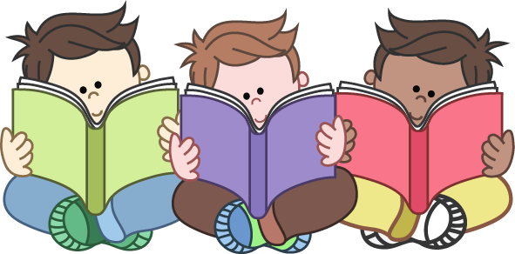



Concept Shopping means the activity of exchanging of goods for money. So, we are as a buyer or a seller we need to know the languages of expressions about shopping, asking for things and bargaining the price.

การซื้อขายสินค้า หมายถึง กิจกรรมของการดูหรือการซื้อสินค้าจากร้าน ดังนั้น เราในฐานะผู้ซื้อ หรือผู้ขายจำเป็นต้องเรียนรู้ภาษา สำนวนและวัฒนธรรมการสอบถามสินค้า การต่อรองราคา การซื้อขายสินค้า

1. Speak in the different situation about shopping correctly.

(พูดสนทนาสอบถามสินค้าตามสถานการณ์ที่แตกต่างกันได้ถูกต้อง)

2. Use the sentences correctly about asking the price and selling goods.

(ใช้ประโยคการสอบถามราคาสินค้าได้ถูกต้อง)

3. Choose the correct determiner suitable in each context.

(เลือกการใช้คำนามแสดงตำแหน่งการสนทนาการซื้อขายสินค้าได้ถูกต้อง)

4. Read the passages about different shopping situation and answer the questions correctly.

(ฟัง พูด อ่าน เขียนวัฒนธรรมการซื้อขายสินค้า แล้วตอบคำถามได้ถูกต้อง)

5. Write sentences to complete the conversation

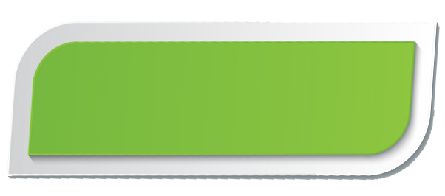

*1. If you were to sell one thing, what would you sell and why.*

*(you as a seller)*

🞎 Grocery 🞎 clothes

🞎 Cosmetics 🞎 souvenirs

🞎 Flowers 🞎 furniture

🞎 Mobile phones 🞎 CDs / DVDs

🞎 Electronics 🞎 Vehicles

🞎 Books 🞎 Other

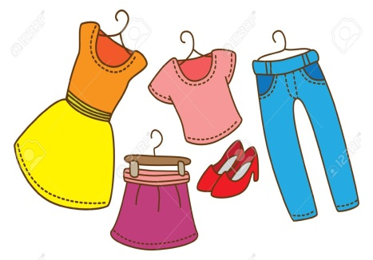

*2. Which greeting is appropriate for the picture?*

*Yes, I’m looking for a green sweater*.

……………………………………………………

 

a. Can I help you?

b. How much is it?

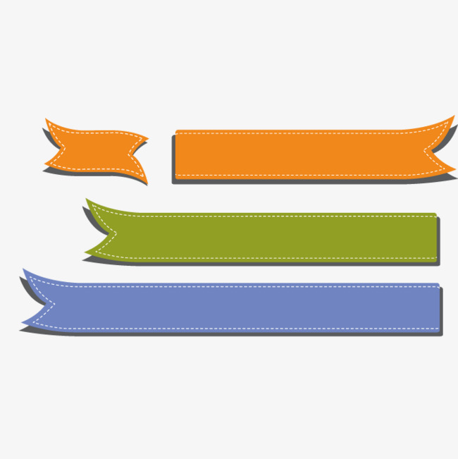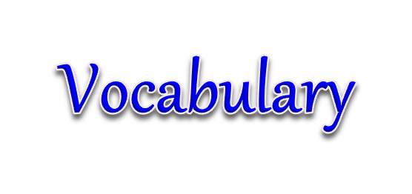

*Who are you?*

|  |  |
| --- | --- |
| **ผู้ซื้อ** | **ผู้ขาย** |
| customer  purchaser  buyer | seller  shop assistant  shopkeeper  salesperson  vender |

*Put these items in the right department in the shop. There are four items in each department.*

|  |
| --- |
| bracelet lamp necklace vegetable table  Television suit bed earrings bookshelf  bread microwave laptop meat T-shirt  trousers blouse brooch fruit refrigerator |

**Clothing**

……………………………………………………………………………………………………………….………

……………………………….………

……………………………….………

**Household goods**

……………………………………………………………………………………………………………….………

……………………………….………

……………………………….………

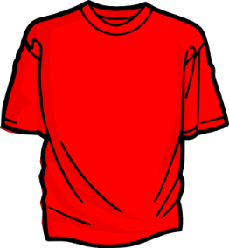

**Electronic appliances**

……………………………………

……………………………………

……………………………………

……………………………………

……………………………………

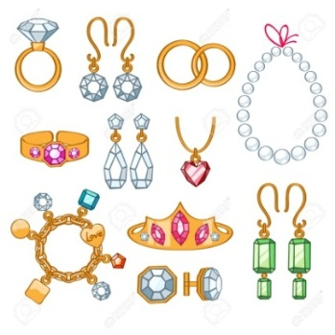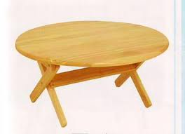

**Accessories**

……………………………………………………………………………………………………………….……

……………………………….……

……………………………….……

**Grocery**

……………………………………………………………………………………………………………….……

……………………………….……

……………………………….……

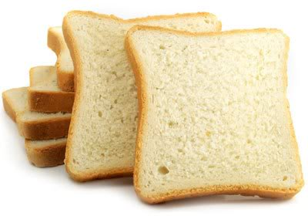

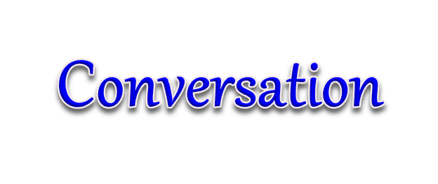

***Conversation 1***

***Situation: Nan is looking for shoes at Chaisaeng Department Store to wear to a wedding.***

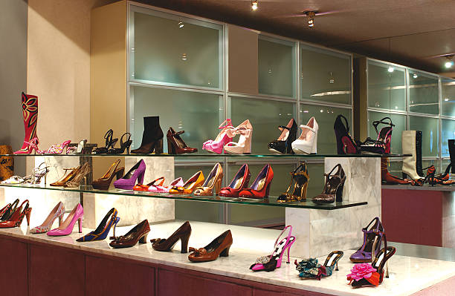

*A. Listen and repeat.*

Nan: Excuse me.

Salesperson: Good afternoon. Can I help you?

Nan: How much are these shoes?

Salesperson: They are 600 baht a pair.

Nan: Can I try them on?

Salesperson: Sure, go ahead.

Nan: Can you give me a discount?

Salesperson: I’m sorry. It is the best price I can offer.

Nan: Oh…I see. Then I guess I won’t buy them.

Salesperson: That’s OK.

*B. Complete the conversation based on what you hear.*

Sweater / skirt / hat / skirt / dress / jacket / T-shirt / scarf /

Pants / trousers / socks / gloves / glasses / earrings

**A:** Excuse me.

**B:** Hello. Can I help you?

**A:** How much are these ­__________?

**B:** They are ________. (Number)

**A:** Can you__________?

**B:** I’m sorry. It is the best price I can offer.

**A:** Oh…I see. Then I guess I won’t buy them.

**B:** That’s OK.

*Conversation 2*

***Situation: Cake and June go shopping for clothes at Central Department***

***Store.***

***A. Listen and repeat.***

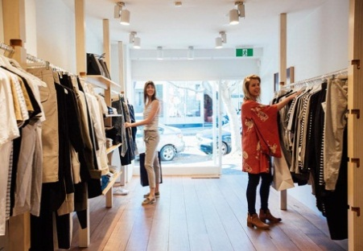 Cake: Isn’t this skirt cute?

June: Yes, it will look good on you.

Cake: Excuse me. How much does it cost?

Seller: 300 baht.

Cake: Can I have a discount?

Seller: I’m sorry. It is cheap already.

Cake: But it is too expensive for me. Can I have it for 250 baht?

Seller: I can only give it to you at 270.

Cake**:** Okay, I’ll take it.

***B. Form a conversation based on the words given.***

Sweater / skirt / hat / skirt / dress / jacket / T-shirt / scarf

**A:** Isn’t this __________ cute?

**B:** Yes, it will look good on you.

**A:** How much is it?

**C:** __________ baht. (Number)

**A:** Can I have a discount?

**C:** It is cheap already.

**A:** But it is too expensive for me. Can I have it for ________ baht? (Number)

**C:** I can only give it to you at __________. (Number)

**A:**  Okay, I’ll take that.

*Conversation 3*

***Situation:*** *Pop is helping her mother sell BBQ at the market.*



***A. Listen and repeat.***

Pop: Good morning. What can I do for you?

Buyer: Hello. What are these?

Pop: These are pork, and chicken BBQs.

Buyer: How much is it?

Pop: The regular price is 20 baht per stick. A special offer is 3 for 50 baht.

Buyer: Oh, I just want to try. I’ll take one pork, thank you

Pop: Thank you very much

***B. Complete the conversation based on what you hear.***

Who are they / what is it / what are these / what is this / how much / how many / do you need help?

Pop: Good morning. What can I do for you?

Buyer: Hello. _____________?

Pop: These are pork, and chicken BBQs.

Buyer: ________ are they?

Pop: The regular price is ____ baht per stick. A special offer

is 3 for ___ baht. (Number)

Buyer: Oh, I just want to try. I’ll take one pork, thank you

Pop: Thank you very much.

*Conversation 4*

*Situation: While Joy (seller) works in the bag shop, Mint (purchaser) sees a beautiful handbag. Jane does not hesitate to take a closer look and ask about the price.*

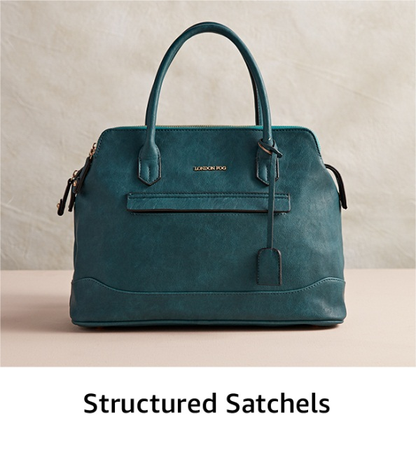

***A. Listen and repeat.***

**Jane:** Oh, that bag looks gorgeous! Excuse me.

**Mint:** May I help you, Ms?

**Jane:** How much is this bag?

**Mint:** It is 2,300 baht. But, the store has a new campaign to offer 20 percent

discount when you register for a membership card.

**Jane:** How much does the registration cost?

**Mint:** It costs 100 baht per year.

**Jane:** Okay, I will do one. But do you have other colors for this style?

**Mint:** Sorry, this is the only color we have.

**Jane:** Never mind. I’ll take this one.

***B. Form a conversation based on the words given.***

Sweater / skirt / hat / skirt / dress / jacket / T-shirt / scarf / necklace / bracelet / ring / watch / sofa / laptop /

**A:**  Oh, that _____ looks gorgeous! Excuse me.

**B:**  May I help you, ____?

**A:**  How much is this ____?

**B:** It is ______ baht. But, the store has a new campaign to offer _____ percent discount when you register for a membership card. (Number)

**A:** How much does the registration cost?

**B:** It costs _____ baht per year.

**A:**  Okay, I will do one. But do you have other colors for this style?

**B:**  Sorry, this is the only color we have.

A: Never mind. I’ll take this one.

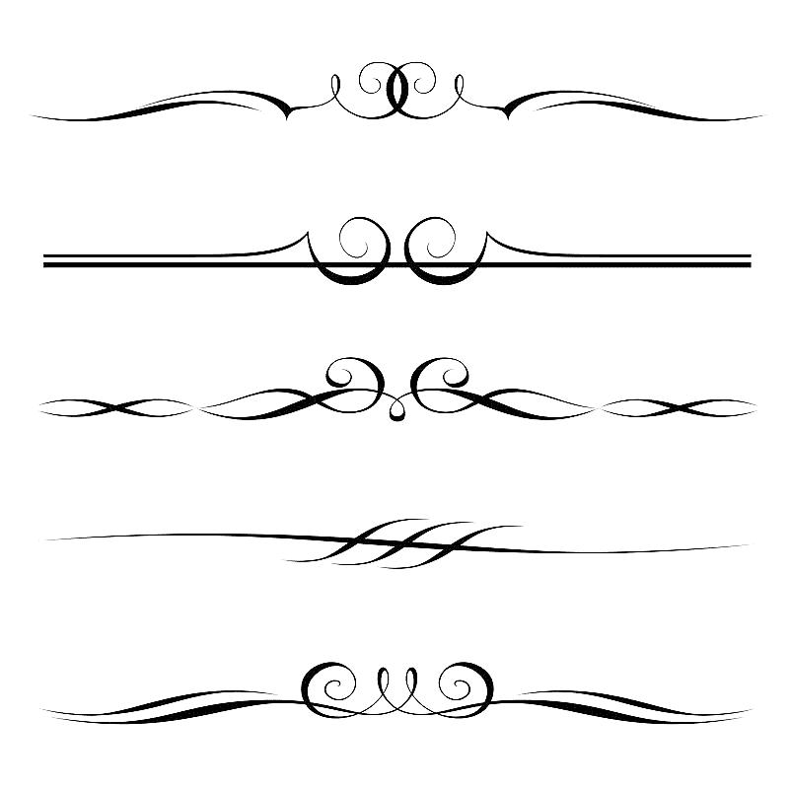

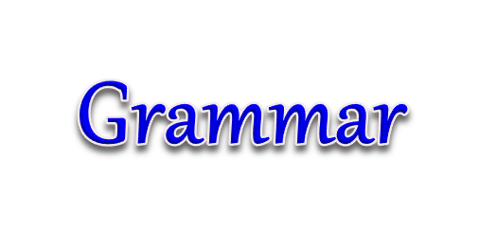

***Expressions for shopping***

|  |  |
| --- | --- |
| **Salesperson** | **Customer** |
| **Greetings and offering help:** | **Asking for things:** |
| Good morning/ afternoon / evening   * Can/Could/May I help you? * What can I do for you? * What are you looking for? | Do you have any…. (things)….?  I’m looking for……………..  I want…………………..  I wonder if you could help me find……..? |
| * Are you looking for anything in particular? | **Reply:**  - I’m just looking, thank you.  - Please show me…………….. |
| **Telling price:** | **Asking price:** |
| * Its ………….…….baht/ dollars. | - How much is it?  - How much does it cost?  - How much is ……..? |
| * There’re…………….baht/ dollars. | - How much are they?  - How much do they cost? |
| **Reply:** | **Bargain:** |
| - I’m sorry. The price is fixed/reasonable.  - I’m sorry. That’s the best/last price.  - I can give you ………… baht/ discount. | - That’s too expensive.  - Can you give me a discount?  - Can you lower the price?  - Can I have it at ………………? |

***Others Expressions* (สำนวนอื่น ๆ ในการสนทนาการซื้อขายสินค้า)**

|  |  |
| --- | --- |
| **Question** | **Answer/Comment** |
| - What size would you like to wear? | - I wear size S/ M / L/ XL. |
| - What color do you want? | - I want the red one, please. |
| - How would you pay? | - Cash or Credit card. |
| - Can I try it on? | - Yes, please. The fitting room is over there. |
| - Do you have a smaller/ larger one? | - Yes, we do. |
| - How do you like it? | - I’ll take it.  - No, I’ll leave it for now. Thanks anyway. |

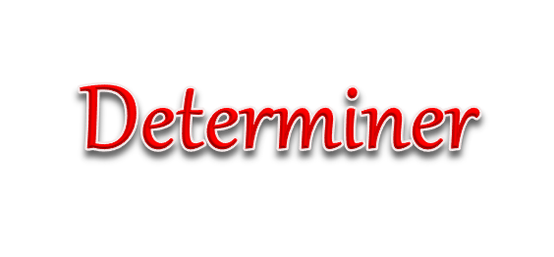

***Determiner can be defined as any word that is used before a noun to particularly show which thing you mean.***

**Articles**

***In general***

* **A**: used with singular countable nouns those begin with non-vowel sounds.
* **An**: used with singular countable nouns those begin with vowel sounds.
* **Zero article**: plural countable nouns and non-countable nouns.

**In particular**

* The: used with singular and plural countable nouns as well as non-countable nouns (all types of nouns).

***Exercise: Complete the sentences using a, an, the or no article (-).***

1. I buy ______ furniture today.

2. Can you see _______ blue bag there?

3. She wants to buy _______ new bracelet.

4. _____ orange provides vitamin C which is good for your skin.

5. We often buy _____ onion.

6. He is searching for _______ wooden sofa.

7. ______ sweater you are wearing is beautiful.

8. I don’t like _____ pink trousers.

9. Do you have ______ T-shirt?

10. They are purchasing _______ electronic device.

**Demonstrative**

|  |  |
| --- | --- |
| **Demonstrative** | **Usage** |
| This  These | **-** to talk about people or things **near the speaker** |
| That  Those | -to talk about things that are **far from the speaker** |

***Exercise:*** *Complete the sentences using* ***this, that, these*** *or* ***those.***

1. She doesn’t like (these/those) ________ blue jeans over there.
2. Look!!(these/this) _________shoes are very nice.
3. How much do (those /this) _________ earrings cost?
4. (That/Those)__________ computer looks amazing.
5. (Those/This) ______________is a beautiful handbag.
6. Do you like (these /this) _____________lamp?
7. We love (this, that)__________table but we don’t like that one.
8. How much are (that, those)________________ shoes?
9. Can I look at (this/these)___________ dress?
10. They want to buy (that/those) __________ carrots.

One/Ones

* used to avoid unnecessary repetition

Example:

A: May I see that shirt?

B: Which **one do you want to see**?

A: The purple one.



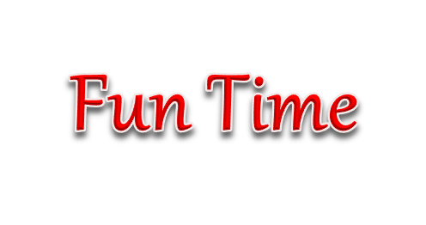



Individual Work: if you could sell one thing from what you have now. What would it be? Why? and How much?

**Example:**

*I would sell this skirt for 80 baht because I will buy a bigger one.*

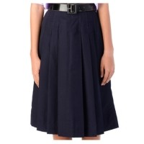

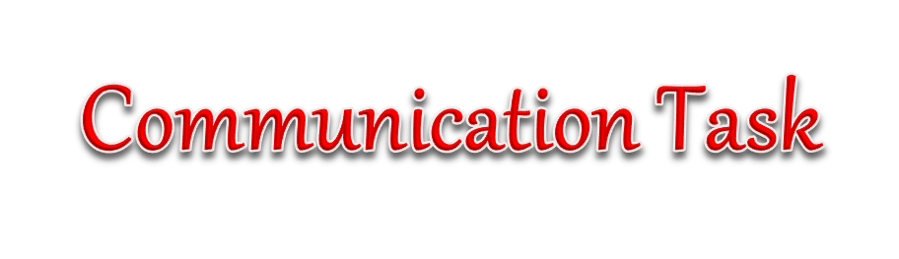

***Write two short conversations with the shop assistant. Then practice with your partner.***

*Shop Assistant: Good morning, can I help you?*

*You: ___________________________________*

*Shop Assistant: ___________________________*

*You: ___________________________________*

*Shop Assistant: __________________________*

*You: ___________________________________*

*Shop Assistant: Good afternoon, may I help you?*

*You: ___________________________________*

*Shop Assistant: __________________________*

*You: ____________________________________*

*Shop Assistant: ___________________________*

*You: _____________________________________*



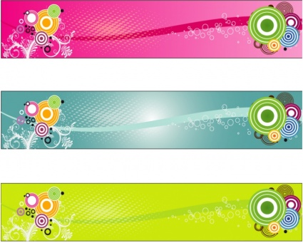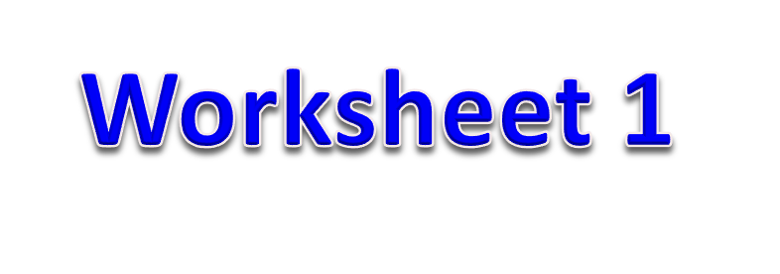

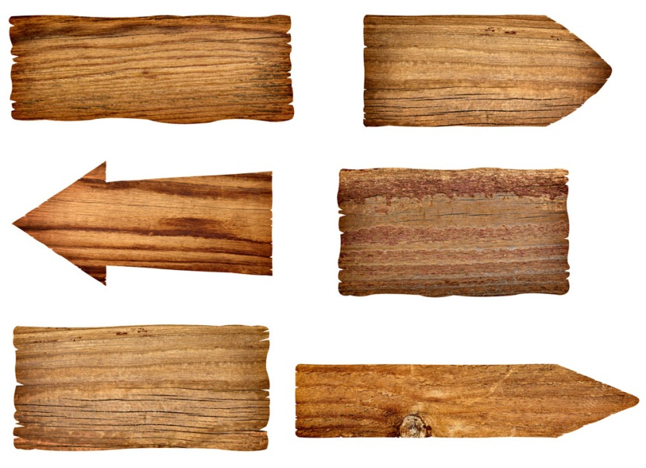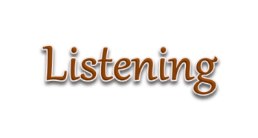

***Listen to the conversations and complete the sentences.***

***Conversation 1*: At the shopping mall.**

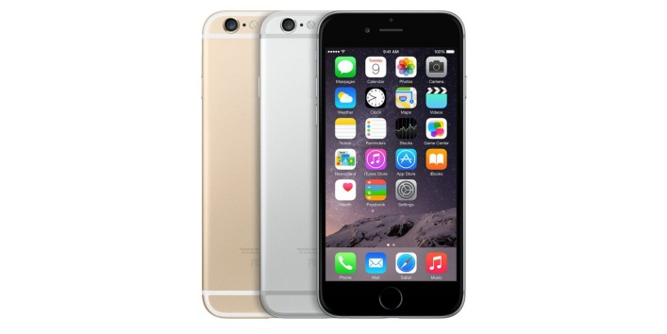

**Kam:** I’m looking for a _____________. May I see that one?

**Owner:** ______________________?

**Kam:** The black one.

**Owner:** Oh, this one?

**Kam:** Yes. _________________?

**Owner:** It costs 20,000 baht.

**Kam:** Oh, that’s expensive. _____________________?

**Owner:** _______________, this is the cheapest model that I have.

***Conversation 2:* At the supermarket**

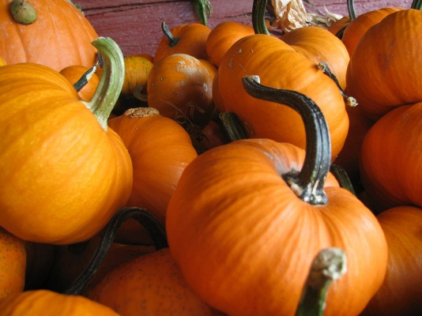

**Seller:** May I help you?

**Nan:** Excuse me. _____________________?

**Seller:** This pumpkin is imported from USA. It’s normally

60 baht per kilogram.

**Nan:** Oh,_____________________.

**Seller:** You can take a look at these cheaper ones. They are from Vietnam and Malaysia.

**Nan:** ________________________?

**Seller:** They are 40 baht per kilogram.

**Nan:** Ok, I’ll take one.

***Conversation 3: At the furniture store***

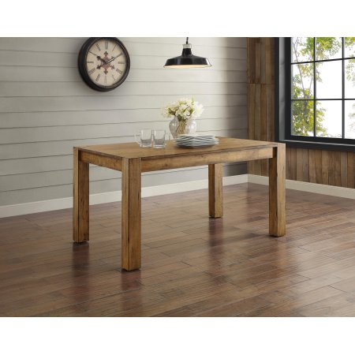

**June:**  Excuse me. May I ask a question?

**Salesperson:**  Sure. ______________________, Madame?

**June:**  Is this dining table is on sale?

**Salesperson:**  Yes, it was 10,000 baht but now it is ______ baht.

**June:**  Wow, this is a good discount. _______________?

**Salesperson:**  There are black and light brown available.

**June:**  Oh, I don’t like these colors.

**Salesperson:** ____________________. I can show you around.

**June:** Never mind. Thank you very much.

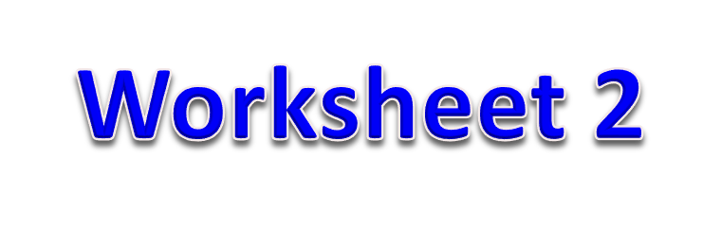

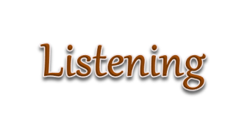

*Listen to the conversation, then complete it by using the giving words or phrases.*

Salesperson: Excuse me . Can (1) _______________________?

Customer: Yes, please.

Salesperson: What are you (2) _______________________?

Customer: I need a cocktail dress.

Salesperson: Sorry, we’re (3) _________________cocktail dresses.

Customer: I see. Do you have any hat?

Salesperson: Yes, in the hat section.

Customer: How much (4) ___________________?

Salesperson: Two hundred baht.

Customer: That’s too (5) _______________.

Salesperson: How about these?

Customer: (5) _______________are they?

Salesperson: One hundred and seventy-nine baht.

Customer: I’ll take them.

Salesperson: (7)________________else?

Customer: No, that’s it.

Salesperson: (8)________________or credit card?

Customer: (9)_______________the cash.

Salesperson: (10)________________for shopping with us.

***Choice for 1-10***

1. Out of f. are these
2. Expensive g. Here’s
3. Anything h. I help you
4. Thank you i. How much
5. Cash j. looking for

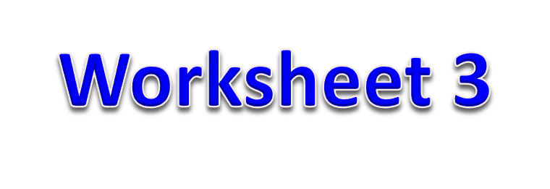

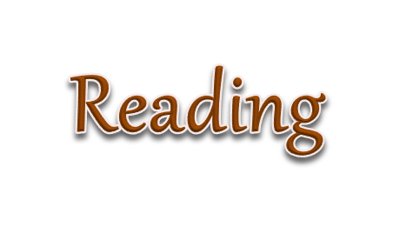

***Read this conversation then answer the questions.***

Salesperson: Can I help you sir?

Customer: Yes, please. I’m looking for a sweater.

Salesperson: What color would you like?

Customer: Grey.

Salesperson: And what size do you wear?

Customer: I wear size L.

Salesperson: Here you are. How do you like it?

Customer: It’s nice. I’ll take it. How much does it cost?

Salesperson: 499 baht.

Customer: Can you give me a discount?

Salesperson: I’ll give you 10% discount. How would you like to pay?

Customer: Cash.

***Answer the questions.***

1. What does the customer buy?

…………………………………………………………………………2. How much does the customer spend?

…………………………………………………………………………3. Does the customer decide to buy the shirt?

…………………………………………………………………………4. Does the salesperson give the customer a discount?

…………………………………………………………………………5. Does the customer pay by cash?

…………………………………………………………………………

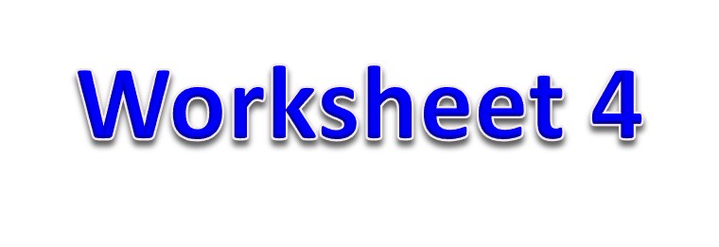

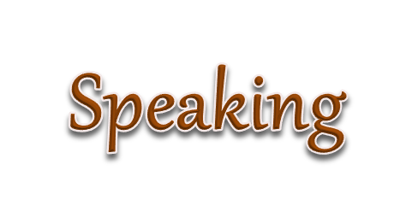

***Pair work: Complete the conversations with the appropriate words and practice with a partner.***

|  |  |
| --- | --- |
| ผลการค้นหารูปภาพสำหรับ tv | **A:** Good afternoon, ____________?  **B:** ___________________.  **A:** What brand do you like?  **B:** ___________________. |
| ผลการค้นหารูปภาพสำหรับ two necklacesผลการค้นหารูปภาพสำหรับ two necklaces | **A:** ______________ is this necklace?  **B:** _________ 2,000 baht.  **A:** What about that one? ____________?  **B:** That’s 3,200 baht. |
| ผลการค้นหารูปภาพสำหรับ pants | **A:** How much ___________ these pants?  **B:** __________599 baht.  **A:** Can you give me a ____________?  **B:** Yes, 550 baht. |
| ผลการค้นหารูปภาพสำหรับ shoes | **A:** How much are those ____________?  **B:** They’re _______ baht, Would you like  to try them on?  **A:** Uh, no. That’s OK! But thanks anyway.  **B:** _______________. |

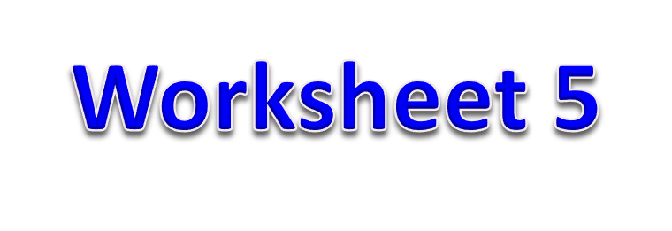

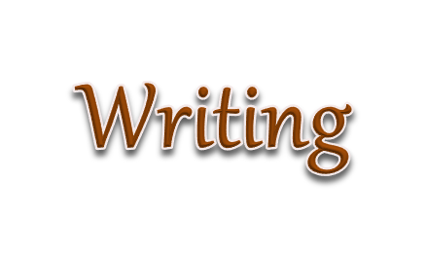

***Complete the conversation with the words you have learned***

***Conversation:* At the department store.**

Shop assistant: Excuse me. Can _______________?

Customer: Yes, please.

Shop assistant: What are you _______________?

Customer: I need two pairs of socks.

Shop assistant: They’re in the sport section.

Customer: I see. Do you have any athletic shoes on sale?

Shop assistant: Yes. Here they are.

Customer: How much _______________?

Shop assistant: 750 baht.

Customer: That’s too _______________

Shop assistant: How about these?

Customer: _______________ are they?

Shop assistant: 550 baht.

Customer: I’ll take them.

Shop assistant: _______________else?

Customer: No, that’s all.

Shop assistant: _______________by credit card?

Customer: I’ll pay in cash.

Shop assistant: ………….....Good-by

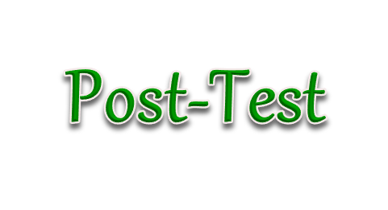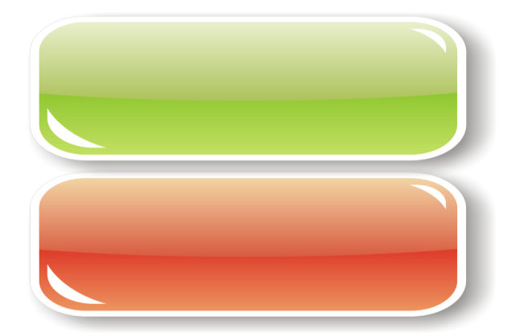

***Part I: Choose the correct answer***

1. Customer: May I see _____ ones?

a. this

b. that

c. those

d. one

2. A: Which trousers do you want to buy?

B: ……………………..

a. The red one

b. The black one

c. The blue ones

d. The larger ones

3. Seller: How do you like it?

Buyer: ……………………

a. I think it’s too large

b. I’ll come back again.

c. What size do you wear?

d. Visa card is acceptable.

4. Buyer: ……………………..?

Seller: It costs 380 baht.

a. How do you like it?

b. May I help you?

c. How would you like to pay?

d. How much does it cost?

5. Vendor: Excuse me, sir. ……………………...

Customer: Yes, I’m looking for a T-shirt.

a. May I help you?

b. How about this one?

c. How would you like to pay?

d. What size do you wear?

6. Nook needs to buy a new toy at the shop. She is a ________.

a. seller

b. salesperson

c. customer

d. salesman

7. Customer: ___________________________

Salesperson: Sure, madam. The fitting room is over there.

a. Can I try it on?

b. Where is the fitting room?

c. Can you give me discount?

d. How much is it?

8. Buyer: ___________________________

Seller: This way, please. We have many styles of dresses.

a. I want a medium size.

b. Can I try it on?

c. I want to buy a shirt.

d. I’m looking for a dress.

9. James sees a sweater that he likes, but they are too small.

So, he asks the salesperson, “______”

a. Will you sell me a bigger size?

b. Do you have a smaller size?

c. Can you make it bigger, please?

d. Do you have a larger size?

10. Customer: ___________________________

Owner: I’m sorry, Madame. Only cash is accepted.

a. Can I pay by credit card?

b. Can you lower the price?

c. Do you have another color?

d. Please give me a receipt.

11. Customer: Do you have a light brown scarf?

Shopkeeper: ____________________________

a. Please sign your name here.

b. Please wait a minute, I’ll pack it.

c. What color do you need?

d. Sorry, we’re out of that color.

12. Seller: How would you like to pay?

Buyer: _____________________

a. Do you have another color?

b. I’ll take it.

c. I’ll pay in cash.

d. Can you give me a discount?

13. Customer: _____________________________

Vendor: They are 800 baht.

a. How much does it cost?

b. How much do they cost?

c. How much is it?   
d. Can I pay by cash?

14. Shop assistant: It’s 650 baht.

Buyer: _______________. Do you have a cheaper one?

a. That’s expensive

b. That’s already cheap.

c. I’ll take it.

d. Can you give me at 800 baht?

15. Paul sells things in the shop. She is………………….

a. purchaser

b. a shop assistant

c. a shop helper

d. customer

***Part II: Choose the best answer to complete the following conversation. (16-20)***

Seller: Excuse me. 16)………………?

Customer: Yes, please.

Seller: What are you looking for?

Customer: I am looking for a jacket.

Seller: Yes, 17)…………………..

Customer: How much 18)…………………..?

Seller: It is 1200 baht.

Customer: That’s too expensive. 19)………………

Seller: 990 baht.

Customer: I’ll take it.

Seller: 20)………………………

Customer: No, that’s all.

16. a. Can you help me

b. Can I help you

c. What do you need

d. Can I buy it

17. a. in the shoe department

b. in the clothing department

c. in the supermarket

d. in the drugstore

18. a. are they

b. are you

c. do they

d. is it

19. a. May you sell them to me?

b. May I lower the discount?

c. Can you give me a discount?

d. Can I give you a discount?

20. a. Can I try it on?

b. I’ll take it.

c. Thank you.

d. Anything else?

** The end of exam**

