

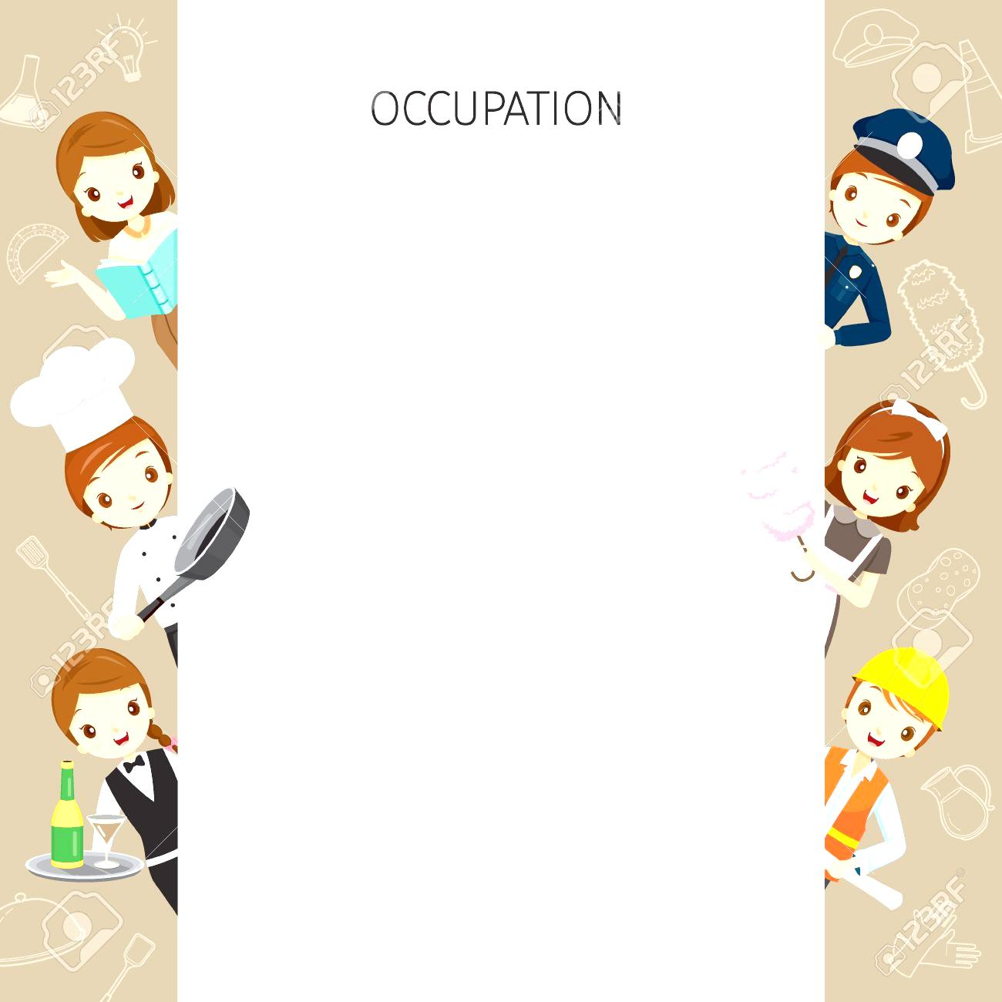

1. Pre-Test
2. Vocabulary/Expressions/phrases
3. Conversation Practice:
4. Grammar Focus: Present simpletense, Verb to be
5. Worksheet

5.1: Listening

5.2: Speaking

5.3: Reading

5.4: Writing

6. Post-test

***Lesson objectives:***

**Student(s) will be able to:**

* Talk about jobs and workplaces

✓ Question and answer about jobs and occupations

using simple present tense

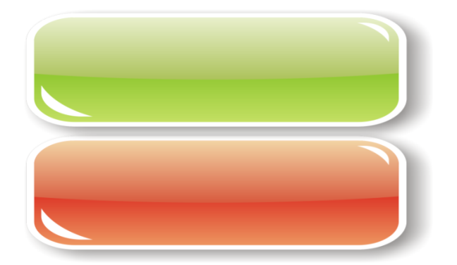

***Part I: Choose the correct answer.***

1. Is it suitable to ask how much money a person earn?

a. OK.

b. Sure.

c. Yes, it is.

d. No, it isn’t.

2. A: What do you do?

B: I…………… an engineer.

a. is

b. am

c. are

d. do

3. A: Are you a teacher?

B: …………………….

a. Yes, I do.

b. No, thank you.

c. Yes, I am.

d. Yes, I am not.

4. A: Where do you work?

B: I work at Singburi hospital. I am ……………

a. a secretary

b. a nurse

c. an engineer

d. a teacher

5. A: Does Pornthip work in the city?

B: …………………….

a. Yes, she do.

b. Yes, she is.

c. Yes, she does.

d. No, she is not.

6. A: …………………………?

B: I’ve been working here for 5 years.

a. What do you do?

b. What do you for living?

c. How long have you been working here?

d. What do you like to do?

7. A: What you want to be in the future?

B: I want to be __________.

a. playing games

b. watching television

c. a woman

d. a scientist

8. A: What do they do?

B: ……………………….

a. They are not.

b. They don’t have.

c. They’re children.

d. They are students.

9. A: What ………. your wife ……?

B: She is a dressmaker.

a. is, do

b. do, does

c. do, do

d. does, do

10. A: What do you want to do after retire?

B: I want to …………......

a. read novel books

b. be an architect in the future

c. travel around Thailand

d. eat vegetables

11. A: …………………..?

B: She works on an airplane.

1. Where does she work?
2. Where does she live?

c. What does she do?

d. Whom does she work with?

***Part II: Matching an occupation with its job description***

______12. An architect a. operate the flying control of an aircraft

______13. A pilot b. play a musical instrument

______14. A doctor c. qualified practitioner of medicine

______15. A musician d. design buildings

***Part III: Complete the conversation***

Jan: Good afternoon, Golf. Long time no see!

Golf: Hello, Jan. How are you?

Jan: I’m great. How about you?

Golf: 16) ___________. What do you do?

Jan: 17) I’m a ___________, and you?

Golf: 18) I’m an___________. How long have been working?

Jan: 19) ____________. I have to go now. 20)_____________.

Golf: See you later.

16. a. I am an engineer

b. I like playing soccer

c.. I’m doing well, thank you

d. Good morning

17. a. scientist

b. architect

c.. artist

d. astronaut

18. a. teacher

b. carpenter

c. flight attendant

d. astronaut

19. a. I like my job.

b. My salary is too low.

c. I work for NASA.

d. I’ve been working for 4 years.

20. a. I’m leaving

b. I have a job

c. See you later

d. Good night

**The end of examination**



***Concept***

 Occupation means a job that you do. It is necessary to know how to talk about with someone who wants to know about your job.

A. What are the jobs of the people in your family? Tell the class.

My father is a doctor. My mother is a…………………….. My brother …………….



*What do you do? What do they do? What does she do?*

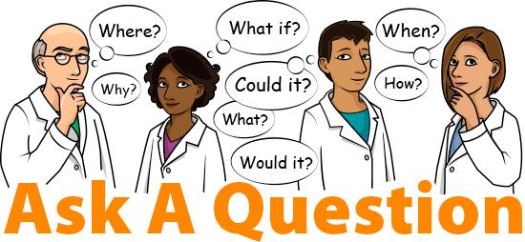

*We are students. They are managers. She is an English teacher.*







*Vocabulary of job and the workplace.*

|  |  |  |
| --- | --- | --- |
| **Jobs** | **Responsibilities** | |
| A salesperson | Sells things at the shop | |
| 1 A chef | Makes food for the hotel guest | |
| 2 A barman | Serves drink at the pub | |
| 3 A postman | Delivers the letters | |
| 4 A teacher | Gives lessons to the students | |
| 5 A student | Study different subjects taught by the teacher | |
| A: What is his responsibility?  B: He is a salesperson. He sells things at the shop.  A: What is your responsibility?  B: I am a salesperson. I sell things in the shop. | | |
| **Jobs** | | **Places of work** |
| 1 A doctor | | In a hospital |
| 2 A shop assistant | | In a shop |
| 3 A waiter/ a waitress | | In a restaurant |
| 4 An administrator | | In a company |
| 5 A policeman/ a policewoman | | In a police station |
| 6 A factory worker | | In a factory |





A: Where does a doctor work?

B: A doctor works in a hospital.

A: What do you do?

B: I am a shop assistant. I work in a shop.

*Conversation*

A: Where do you work?

B: I work at S&P in Bangkok.

A: Do you like your work?

B: Yes, I do.

A: Do you work on Sunday?

B: No, I don’t.

A: How is your job?

B: It’s interesting. I meet many people in the shop.



*A: Write the correct word under each picture.*



*a doctor / a cashier*

*an architect / an artist*

**______________**

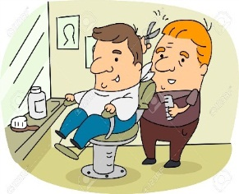

*a barber / a cook/chef*

*a bricklayer / a baby sitter*

**_______________**



*a chef / a cashier /a police officer*

*a computer technician*

**_______________**

 **______________**

*a salesperson / a dancer*

*a dressmaker / a disc jockey (DJ)*



*a surveyor / a secretary*

*a waiter, waitress* ***/*** *a cook, chef*

**______________**



a soldier / a secretary

a nurse **/** a teacher

**______________**



an office worker / a housekeeper

/ a student / a secretary

**_______________**



a chef / a police officer /

a musician / a driver

**_______________**



a scientist / a carpenter

a bricklayer / a baby sitter

**_______________**



a flight attendant / a programmer

an engineer / a singer

**_______________**

*B: Make the sentences with occupations.*



*Aelopicmn*

He’s a policeman.

*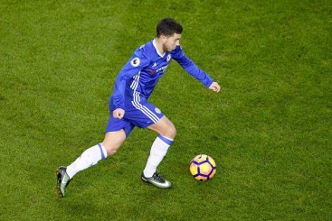 raftbotoell*

…………………………………………………



*dettunss*

…………………………………………………



*acreeth*

…………………………………………………



*sictniste*

…………………………………………………

***C: Match the places of work with occupations.***

|  |  |
| --- | --- |
| **Occupations** | **Places** |
| _________ 1. office worker | a. hospital |
| _________ 2. chef | b. school |
| _________ 3. singer | c. on the plane |
| _________ 4. post officer | d. in a bus |
| _________ 5. doctor | e. department store |
| _________ 6. salesperson | f. post office |
| _________ 7. policeman | g. police station |
| _________ 8. receptionist | h. cinema |
| _________ 9. bus driver | i. restaurant |
| _________ 10. waiter/waitress | g. music company |
| _________ 11. librarian | k. gallery |
| _________ 12. ticket seller | l. library |
| _________ 13. teacher | m. office |
| _________ 14. flight attendant | n. hotel |
| _________ 15. artist | o. kitchen |

***D: Write the duty in A with a jobs in B***

|  |  |
| --- | --- |
| A | A |
| a. designs buildings | f. translates documents |
| b. delivers letters | g. sells things |
| c. look after people in hospital | h. flies planes |
| d. look after money transactions | i. serves drinks |
| e. writes for a newspaper | g. sells products and services |

|  |  |
| --- | --- |
| B | |
| 1. A pilot flies planes. |  |
| 2. An interpreter |  |
| 3. A nurse |  |
| 4. a barman |  |
| 5. An accountant |  |
| 6. A journalist |  |
| 7. A postman |  |
| 8. An architect |  |
| 9. A shopkeeper |  |
| 10. salesperson |  |



***Conversation 1***

**Situation:**

Toon sees Koy who is eating ice-cream beside the football field.

Toon wants to know her more, so he asks about her personal life.

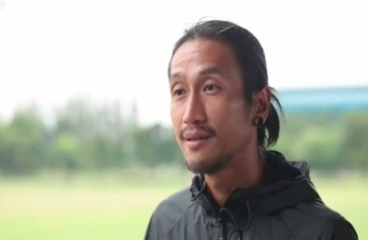



**Toon:** Hey, Koy. May I sit here?

**Koy:** Sure. Take a seat.

**Toon:** What do you do?

**Koy:** I’m an actress. What about you?

**Toon:**  I’m a singer of Body slam.

**Koy:** Sound fun. It’s time for me to leave now. Bye.

**Toon:** Bye.

*Complete the conversation based on what you hear.*

*Hello / May I sit here? / doctor / singer / dancer / drummer / Bye*

**Toon:** Hey, Koy. _________?

**Koy:** Sure. Take a seat.

**Toon:** ________________?

**Koy:** I’m an actress. What about you?

**Toon:**  I’m a __________ of Bodyslam.

**Koy:** Sound fun. It’s time for me to leave now. Bye.

**Toon:** Bye.

***Conversation 2***

**Situation:**

Boy sees a pretty girl at the Public Library. He does not hesitate to say

hello.

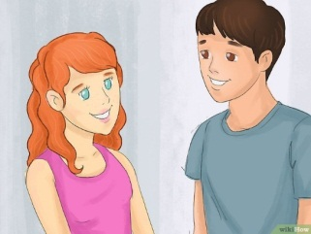

Boy: Hello, there! My name is Boy. What’s your nickname?

Sin: Hi, my name’s Sin.

Boy: What do you do?

Sin: I’m a librarian at Singburi Public Library. What about you?

Boy: I study at Singburi Vocational College.

Sin: Oh, I know that college. It is famous.

*Complete the conversation.*

A: Hello, there! My name is ________. What’s your nickname?

B: Hi, my nickname’s _________.

A: What do you do?

B: _____________ at __________. What about you?

A: I am __________ at Singburi Vocational College.

B: Oh, I know that college. It is famous.

***Conversation 3***

**Situation:**

Amy meets her old friend a restaurant. So, they ask about each other life and family.



Amy: Hello, Sand. Where have you been? I have not seen you for a year.

Sand: Hi, Amy. Glad to see you again. I moved to Bangkok with my family.

Amy: Oh, that’s why. What do you do in Bangkok?

Sand: I work as a secretary at GMM Grammy. What about you?

Amy: I stay home as a housewife. I need to take care my little child.

Sand: Where is your husband? Does he come with you today?

Amy: He works as a pilot so he does not usually stay in Thailand.

Sand: Wow, it sounds fun.

Amy: What about your family? What do your parents do in Bangkok?

Sand: My parents are doctors. My sister is a lawyer.

Amy: Great, send my love to them.

Sand: Definitely. I have to go now. See you again.

Amy: See you then.

***Complete the conversation.***

Amy: Hello, Sand. Where have you been? I have not seen you for a year.

Sand: Hi, Amy. Glad to see you again. I moved to Bangkok with my family.

Amy: Oh, that’s why. ____________in Bangkok?

Sand: I work as a ___________at GMM Grammy. What about you?

Amy: I stay home as a __________. I need to take care my little child.

Sand: Where is your husband? Does not he come with you today?

Amy: He works as a ________ so he does not usually stay in Thailand.

Sand: Wow, it sounds fun.

Amy: What about your family? ____________ in Bangkok?

Sand: My mom is a _______. My sister is a ________.

Amy: Great, send my love to them.

Sand: Definitely. I have to go now. See you again.

Amy: See you then.

***Conversation 4***

**Situation:** Janyaporn is being interviewed for an internship at Four Seasons Hotel.



**Interviewer:** Welcome in, please take a seat.

**Janyaporn:**  Thank you, Ms.

**Interviewer:** Please introduce yourself, briefly.

**Janyaporn:** My name is Janyaporn. I’m twenty years old. I’m a fourth-year student at Singburi Vocational College.

**Interviewer:**  What field do you study in?

**Janyaporn:** My major is food-science.

**Interviewer:** Which position are you applying for?

**Janyaporn:** I would like to apply for chef-assistant.

**Interviewer:**  How long do you want to work here?

**Janyaporn:** I want to work for 3 months.

**Interviewer:** Okay, I will call you back by next Monday to let you know when to start working.

**Janyaporn:** Thank you so much.

***Form a conversation based on the words given***

first year / second year / third year / fourth year / accounting / finance / food-science / hotel management / 5 months / 4 months / 3 months / receptionist / waitress / waiter / programmer-assistant / office worker / secretary

**Interviewer:** Welcome, please take a seat.

**B:**  Thank you, ___________.

**Interviewer:** Please introduce yourself, briefly.

**B:** My name is __________. I’m__________ years old. I’m a _________student at Singburi Vocational College.

**Interviewer:**  What field do you study in?

**B:** My major is __________.

**Interviewer:** Which position are you applying for?

**B:** I would like to apply for ___________.

**Interviewer:**  How long do you want to work here?

**B:** I want to work for____________.

**Interviewer:** Okay, I will call you back by next Monday to let you know when to start working.

**B:** Thank you so much.

 

*Present simple:*

1. The present simple expresses a fact which is always true, or true for a long time.

He works in a bank.

2. It also expresses a habit.

He never has a holiday.

Positive

|  |  |  |
| --- | --- | --- |
| He  She  It | lives | in Australia. |

Negative

|  |  |  |
| --- | --- | --- |
| He  She  It | Doesn’t lives | in France. |

Question

|  |  |  |  |
| --- | --- | --- | --- |
| What | does | he  she  it | work? |
| Does | he  she  it | work? |  |

***Questions related to jobs and personal life***

|  |  |
| --- | --- |
| **Questions** | **Answers** |
| What do you do?  What is your job?  What do you do for a living?  What is your position? | I’m **a teacher.** (occupations)  Or I work as a teacher. |
| What time do you start work? | I start work at **8:00 a.m**. (time) |
| What time do you finish work? | I finish work at **5:00 p.m.** (time) |
| What do you want to be in the future? | I want to be **an engineer.** (occupations) |
| Where do you work? | I work at the airport**.** (place) |
| How do you go to work/school? | I go to work by **car.** (vehicle/foot) |
| Do you like your job? | Yes, I do. It’s **very interesting.** (adjective) |
| What duty are you in charge of?  What are your responsibilities in your company? | I sell the products and introduce the new things.  or  Designing, developing, testing software to meet customer requirement are my responsibilities. |
| Where do you study?  What’s your school | I study at **Singburi Vocational college.** (place) |
| What do you study?  What’s your major? | I study **accounting.** (field of study) |
| How long have you been working here? | I’ve been working here for 3 years. (period of time) |
| Do you work on weekends? | No, I don’t. On Sunday Is my holiday. |
| Do you enjoy working here? | Yes, I do. I am very happy. My colleagues are so friendly. |



*THE PERFECT JOB:*

**Pair work**: You’re looking for a job. Which of these things do you want in a job. First, answer the questions. Then ask your partner the same questions.

|  |  |  |  |  |
| --- | --- | --- | --- | --- |
| Job | Me | | My Partner | |
| **Do you want to ………..?** | **Yes** | **No** | **Yes** | **No** |
| 1. talk to people |  |  |  |  |
| 2. help people |  |  |  |  |
| 3. perform in front of people |  |  |  |  |
| 4. work from 9 to 5 |  |  |  |  |
| 5. work at home |  |  |  |  |
| 6. use a computer |  |  |  |  |
| 7. use the telephone |  |  |  |  |
| 8. work in an office |  |  |  |  |
| 9. have your own office |  |  |  |  |
| 10. work outdoors |  |  |  |  |
| 11. travel |  |  |  |  |
| 12. have an exciting job |  |  |  |  |
| 13. have a relaxing job |  |  |  |  |
| 14. wear a uniform |  |  |  |  |
| 14. wear a suit |  |  |  |  |
| 15. wear blue jeans |  |  |  |  |





*Listen to the conversations and complete the sentences.*

**Conversation 1:** At a birthday party

Nam: ______________________?

Bank: I’m an accountant.

Nam: ______________________, Adam?

Bank: He is a chef at Four Seasons Hotel. Where do you work?

 Nam: ______________________.

**Conversation 2:** At an interview

Mink: _____________________?

Pear: I’m a hotel receptionist.

Mink: What time do you work?

Pear: I work from ______to ____ on weekends.

Mink: Only ________ a week?

Pear: That’s right.

Mink: How long have you been working here?

Pear: I’ve been working here for ___________ years.

Mink: _____________ about your job?

Pear: Since I work only on the weekends, I don’t have much to

do during the week.





*Listen. What do the phrases in bold mean?*

Match the pictures with the sentences a - f.

a. His parents give him some money.

b. He works for some hours a few days of the week.

c. Every week she goes the money she works for.

d. He works for the whole of working week

e. She gets a lot of money from her job.

f. She works many hours a day.

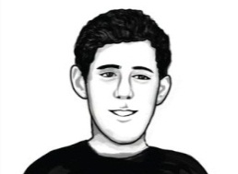

*I need some money for my summer holiday,*

*So I get a* ***part-time job*** *as a waiter.*

1. ___________________________________________



*When I finished school, I got a* ***full-time job*** *at my*

*parents’ shop.*

2. ___________________________________________



*I haven’t found a job yet so I still get* ***pocket money***

*from my parents.*

3. ___________________________________________

*I work at an Internet café and I* ***get paid weekly.***

4. ___________________________________________

**

*I’ve got an interesting job but I have to work*

***long hours*** *every day.*

5. ___________________________________________

**

*I have to work really hard but I* ***make*** *a lot of* ***money****,*

*so I don’t mind.*

6___________________________________________





* ***Pair work: asking and answering questions with your partner. One person asks, the other answer, and vice versa.***

|  |  |
| --- | --- |
| **Questions** | **Answers** |
| 1. What do you do?  2. Where do you study?  3. What do you study?  4. Do you have a part-time job?  5. If yes, how long have you been working?  6. What do you want to be in the future?  7. What does your father do?  8. What does your mother do?  9. What do your brothers/sisters do? | ____________________  ____________________  ____________________  ________________________________________________________________________________________________________________________ |







***Read the dialogue and answer the questions.***



**Ali** is a scientist. She comes from Cambridge in England but now she lives in Switzerland. She works three days a week at the Institute of Molecular Biology in Geneva. She speaks three languages: English, French, and German. She’s married and has a daughter. She likes skiing in winter and going for walks in summer.

**Alison Hauser**

**Bob** is a doctor. He’s English but now he lives in Australia in the small town of Alice Springs. He isn’t an ordinary doctor, he’s a *flying* doctor, Every day, from 8 a.m. to 10 a.m. he speaks to people on his radio, then he flies to help them. He works 16 hours a day non-stop but he loves his job. He isn’t married. He has no free time.

**Bob Nelson**

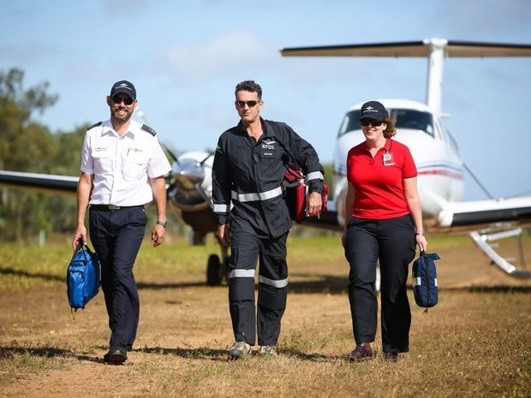

*Complete the sentences about Ali and Bob.*

1. She’s a scientist. He**’s a doctor**.

2. Alison comes from England. Bob_______ _______ England too.

3. She lives in a big city, but he ___________ in a _____________ town.

4. She __________ three days _________ week. He _________ 16 hours

a day _____________ .

5. He ______________ to sick people on his radio. She __________

three languages.

6. She loves her job and he ________ ________ ________, too.

7. She ________ ________ daughter. He _______ married.

8. She _________ skiing and going __________ walks in her free time.

He never _____ free time.





Talking about people

*Read the information about Philippe.*



**Philippe Ballon**

**Job** a barman

**Country** France

**Town** Paris

**Place of work**  in the centre of Paris

**Languages** French, a little English

**Married?** no

**Family** a dog(!)

**Free time** walking his dog, playing

football

*He’s from France and he ………..... Paris.*

*Philippe is a barman.*

*He works ………………..*

*He speaks French and ………………….*

*He isn’t ………………….*

He has …………………..

He likes …………………….





*Reading and speaking*

WHAT DOES SHE DO?

**Questions and Negatives.**

1. Read and listen. Complete the answers. Practice the questions and answers.

Where does Alison come from? Cambridge, _____ England.

What does she do? She’s _______ scientist.

Does she speak French? ______, she does.

Does she speak Spanish? ______, she doesn’t.

*Reading and speaking about grammar: verb to be.*

**GRAMMAR SPOT**

1. What does she/he do? = What’s her/his job?

2. Complete these sentences with the correct form of come.

**Positive**

She _______ from England.

**Negative**

She ____ ____ from America.

**Question**

Where ___ she ___ from?

3. Notice the pronunciation of *does* and *doesn’t.*

**Does** he speak French?

Yes, he does./No, he doesn’t.

*Complete the questions and answers.*

1. Where _____ Bob _____ from?

England.

2. What _________ he ____ ?

He’s a doctor.

3. ________ he fly to help people?

Yes, he _____.

4. _________ he _________ French and German?

No, he __________.





*A: Read the information about Keiko or Mark.*

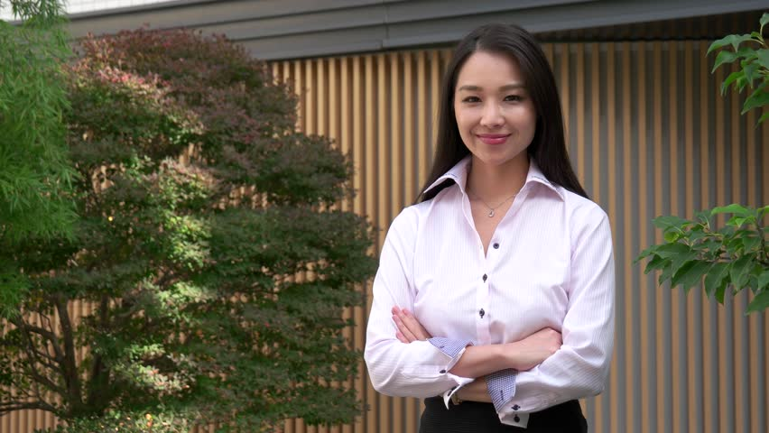

**Keiko Wilson**

**Job** an interpreter

**Country** Japan

**Town** New York

**Place of work** at the United Nations

**Languages** Japanese, English, and French

**Family** married to an American, two sons

**Free time** Skiing

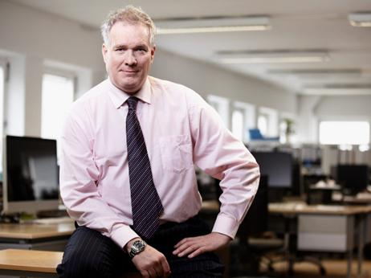

**Mark Konig**

**Job** a journalist for the

BBC

**Country** England

**Town** Moscow

**Place of work** in an office

**Languages** English, Russian, and German

**Family** married, three daughters

**Free time** listening to music

B: Write questions about Keiko or Mark.

1. Where/come from?

***Where does Keiko come from?***

2. Where/live?

_______________________________________

3. What/do?

_______________________________________

4. Where/work?

_______________________________________

5. Does she speak French?

_______________________________________

6. What ___________________ in her free time?

_______________________________________

7. What ___________________ in his free time?

_____________________________ listen to music.

8. How many children ______________________?

_______________________________________





*Write questions about Keiko and Mark.*

**Information about Keiko.**

**Keiko Wilson**

Keiko Wilson

____________________________________________

Job interpreter

Country Japan

Town New York

Place of work at the United Nations

Languages Japanese, English, and French

Family married to an American, two sons

Free time skiing

*1. Where /come from?*

*Where does Keiko come from?*

2. What / do?

_______________________________________

3. Where / live?

_______________________________________

4. Where / work?

_______________________________________

5. How many children _____________?

_______________________________________

6. ______________________listen to music?

_______________________________________

7. ___________ she speak English?

_______________________________________





**Information about Mark**

Mark Konig

_______________________________________

Job a journalist for BBC

Country England

Town Mosco

Place of work in an office

Languages English, Russian, and German

Family married, three daughters

Free time listening to music

*1. Where /come from?*

*Where does Mark come from?*

2. What / do?

_______________________________________

3. Where / live?

_______________________________________

4. Where / work?

_______________________________________

5. How many children _____________?

_______________________________________

6. ______________________listen to music?

_______________________________________

7. ___________ he speak English?

_______________________________________

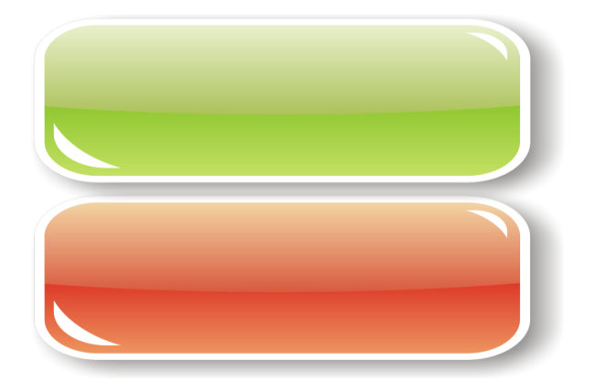

***Part I: Choose the correct answer.***

1. Is it suitable to ask how much money a person earn?

a. OK.

b. Sure.

c. Yes, it is.

d. No, it isn’t.

2. A: What do you do?

B: I…………… an engineer.

a. is

b. am

c. are

d. do

3. A: Are you a teacher?

B: …………………….

a. Yes, I do.

b. No, thank you.

c. Yes, I am.

d. Yes, I am not.

4. A: Where do you work?

B: I work at Singburi hospital. I am ……………

a. a secretary

b. a nurse

c. an engineer

d. a teacher

5. A: Does Pornthip work in the city?

B: …………………….

a. Yes, she do.

b. Yes, she is.

c. Yes, she does.

d. No, she is not.

6. A: …………………………?

B: I’ve been working here for 5 years.

a. What do you do?

b. What do you for living?

c. How long have you been working here?

d. What do you like to do?

7. A: What you want to be in the future?

B: I want to be __________.

a. playing games

b. watching television

c. a woman

d. a scientist

8. A: What do they do?

B: ……………………….

a. They are not.

b. They don’t have.

c. They’re children.

d. They are students.

9. A: What ………. your wife ……?

B: She is a dressmaker.

a. is, do

b. do, does

c. do, do

d. does, do

10. A: What do you want to do after retire?

B: I want to …………......

a. read novel books

b. be an architect in the future

c. travel around Thailand

d. eat vegetables

11. A: …………………..?

B: She works on an airplane.

1. Where does she work?
2. Where does she live?

c. What does she do?

d. Whom does she work with?

***Part II: Matching an occupation with its job description***

______12. An architect a. operate the flying control of an aircraft

______13. A pilot b. play a musical instrument

______14. A doctor c. qualified practitioner of medicine

______15. A musician d. design buildings

***Part III: Complete the conversation***

Jan: Good afternoon, Golf. Long time no see!

Golf: Hello, Jan. How are you?

Jan: I’m great. How about you?

Golf: 16) ___________. What do you do?

Jan: 17) I’m a ___________, and you?

Golf: 18) I’m an___________. How long have been working?

Jan: 19) ____________. I have to go now. 20)_____________.

Golf: See you later.

16. a. I am an engineer

b. I like playing soccer

c.. I’m doing well, thank you

d. Good morning

17. a. scientist

b. architect

c.. artist

d. astronaut

18. a. teacher

b. carpenter

c. flight attendant

d. astronaut

19. a. I like my job.

b. My salary is too low.

c. I work for NASA.

d. I’ve been working for 4 years.

20. a. I’m leaving

 b. I have a job

c. See you later

d. Good night

**The end of examination**